2.3 PARALLAL ADDER

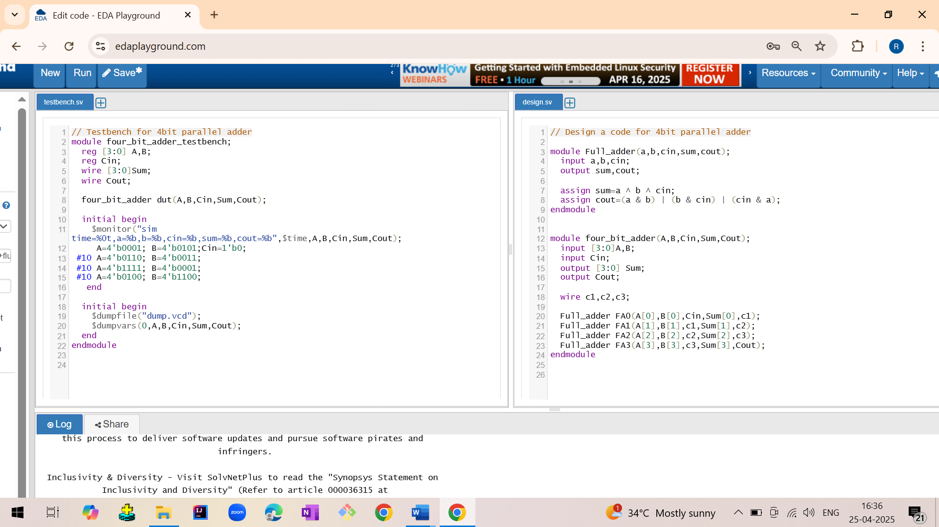

Output:

sim time=0,a=0001,b=0101,cin=0,sum=0110,cout=0  
 sim time=100,a=0110,b=0011,cin=0,sum=1001,cout=0  
 sim time=200,a=1111,b=0001,cin=0,sum=0000,cout=1  
 sim time=300,a=0100,b=1100,cin=0,sum=0000,cout=1

Waveform:

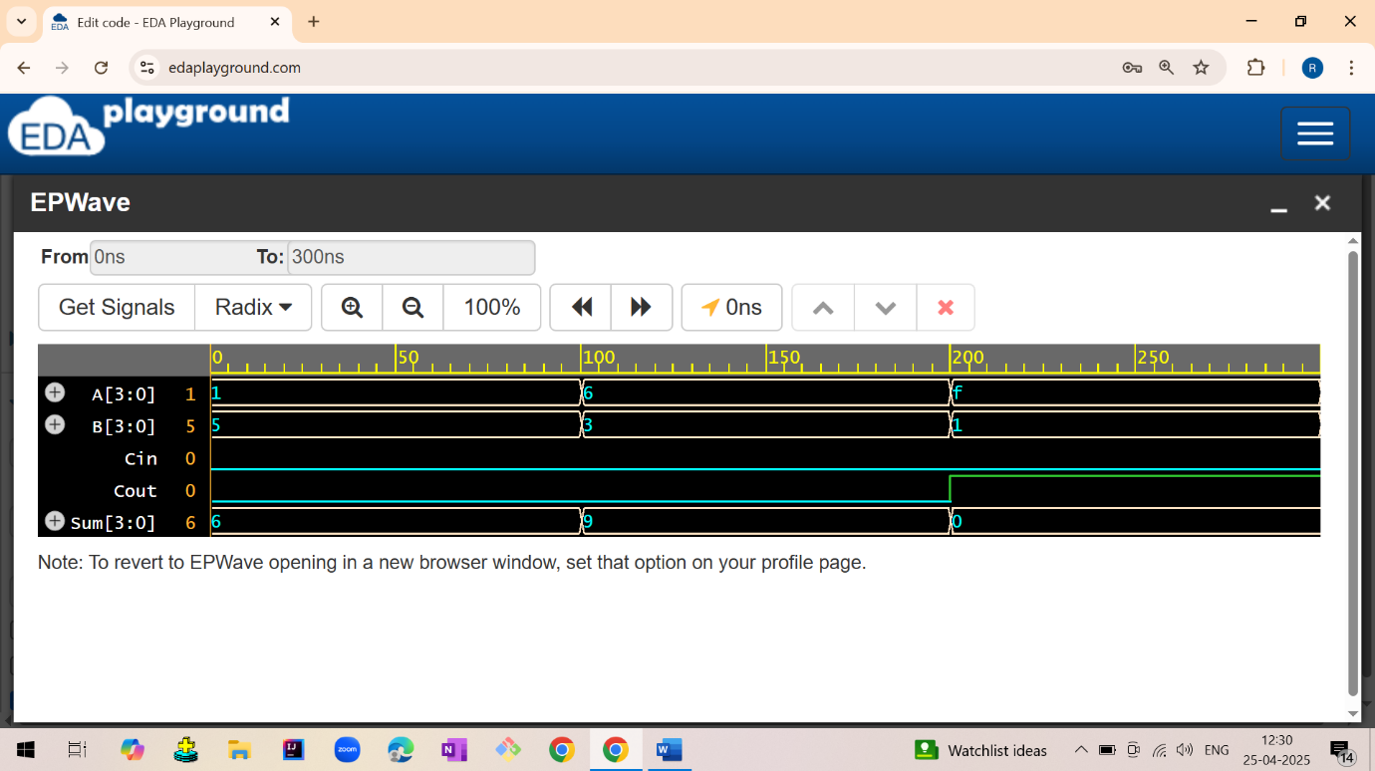

2.4 CARRY LOOK AHEAD ADDER

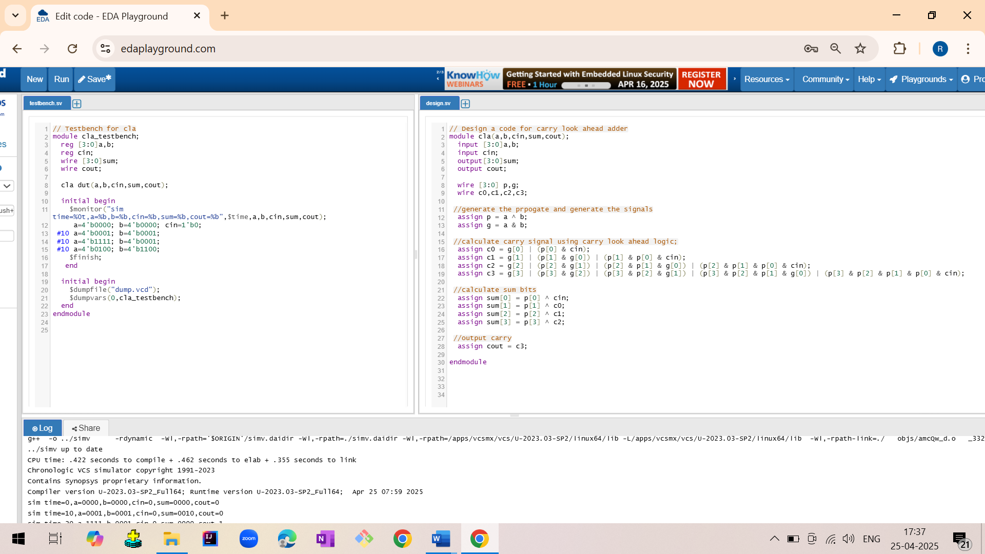

Output:

sim time=0 | a=0000 | b=0000 | cin=0 | sum=0000 | cout=0  
 sim time=10 | a=0001 | b=0001 | cin=0 | sum=0010 | cout=0  
 sim time=20 | a=1111 | b=0001 | cin=0 | sum=0000 | cout=1  
 $finish called from file "testbench.sv", line 16.

Waveforms:

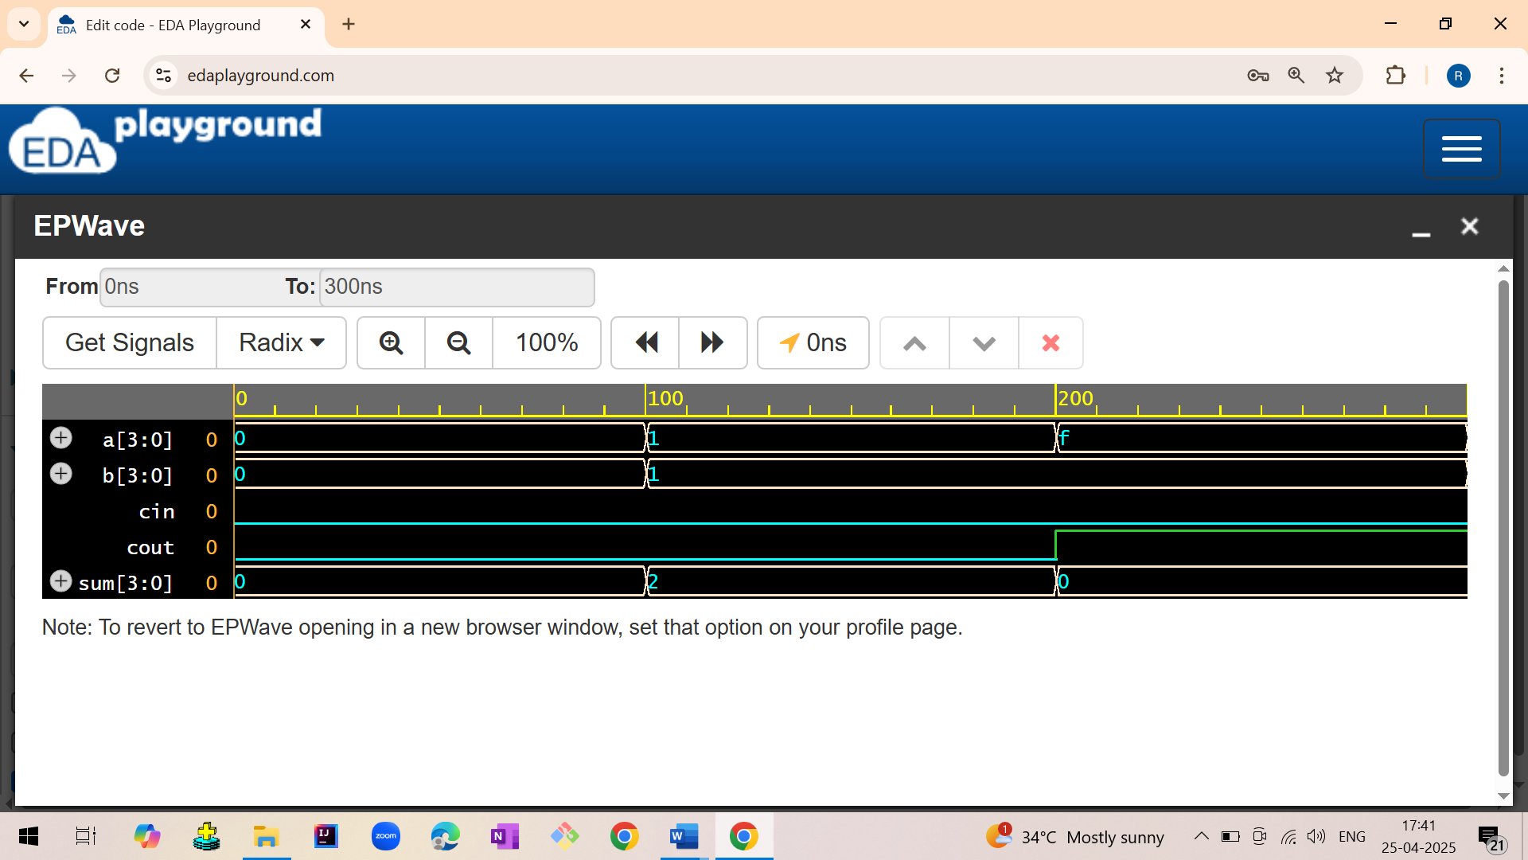

2.5 FULL ADDER USING HALF ADDER

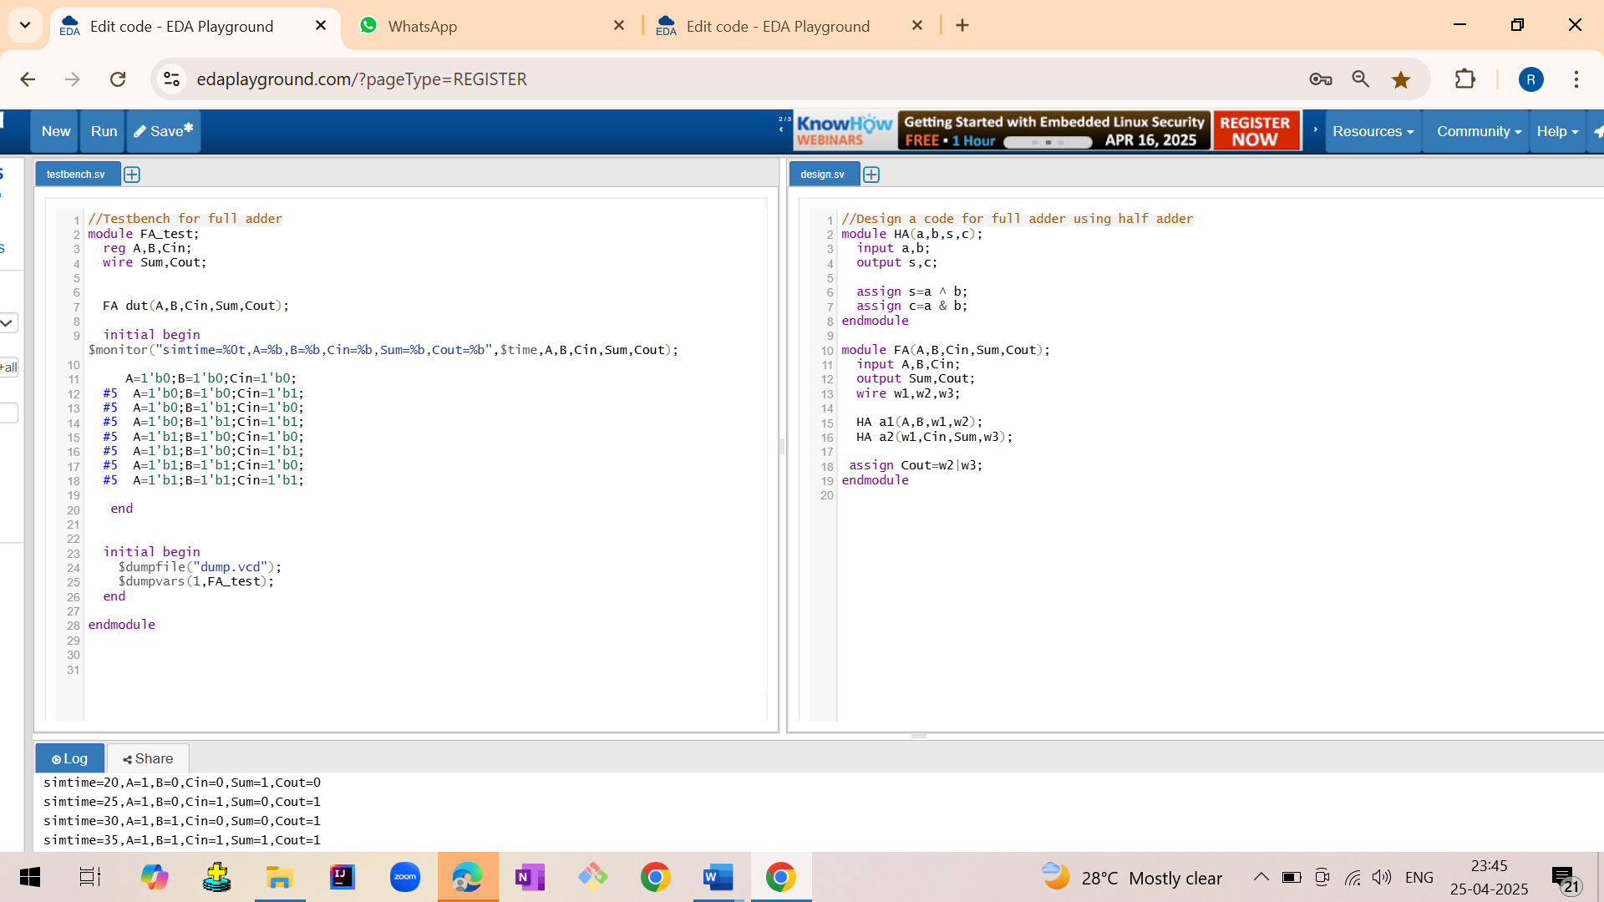

Output:

Sim time=0,A=0,B=0,Cin=0,Sum=0,Cout=0  
 sim time=5,A=0,B=0,Cin=1,Sum=1,Cout=0  
 sim time=10,A=0,B=1,Cin=0,Sum=1,Cout=0  
 sim time=15,A=0,B=1,Cin=1,Sum=0,Cout=1  
 sim time=20,A=1,B=0,Cin=0,Sum=1,Cout=0  
 sim time=25,A=1,B=0,Cin=1,Sum=0,Cout=1  
 sim time=30,A=1,B=1,Cin=0,Sum=0,Cout=1  
 sim time=35,A=1,B=1,Cin=1,Sum=1,Cout=1

Waveform:

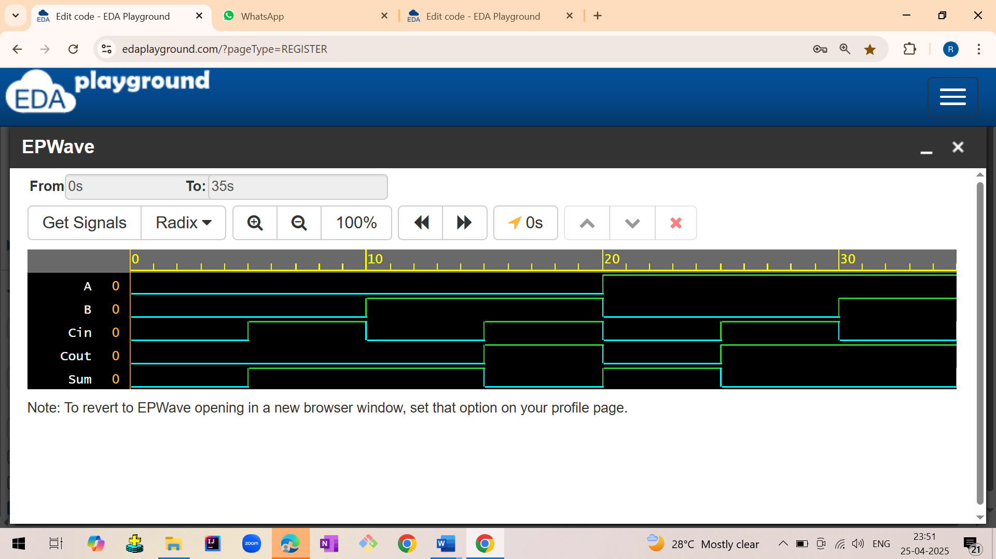

2. ADDER

2.2 Full Adder

2.2.1 Full adder using data flow model

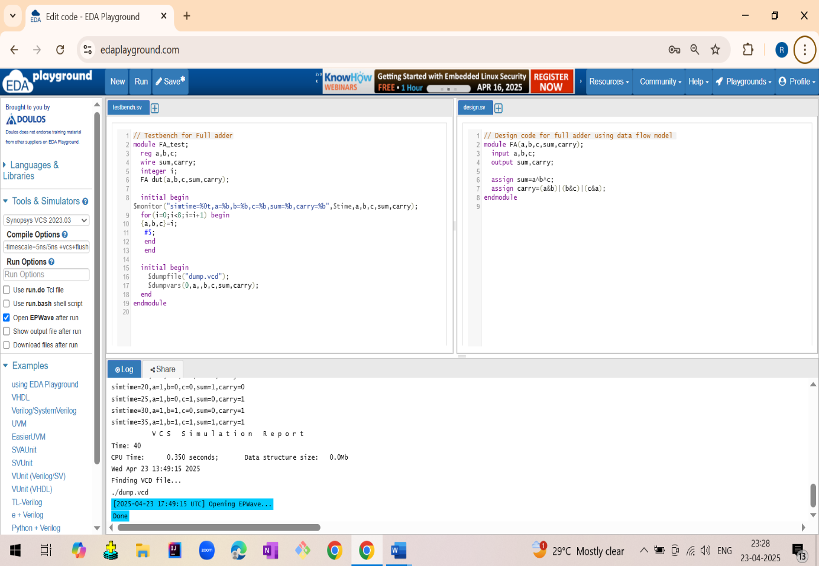

2.2.2 Full adder using gate level model

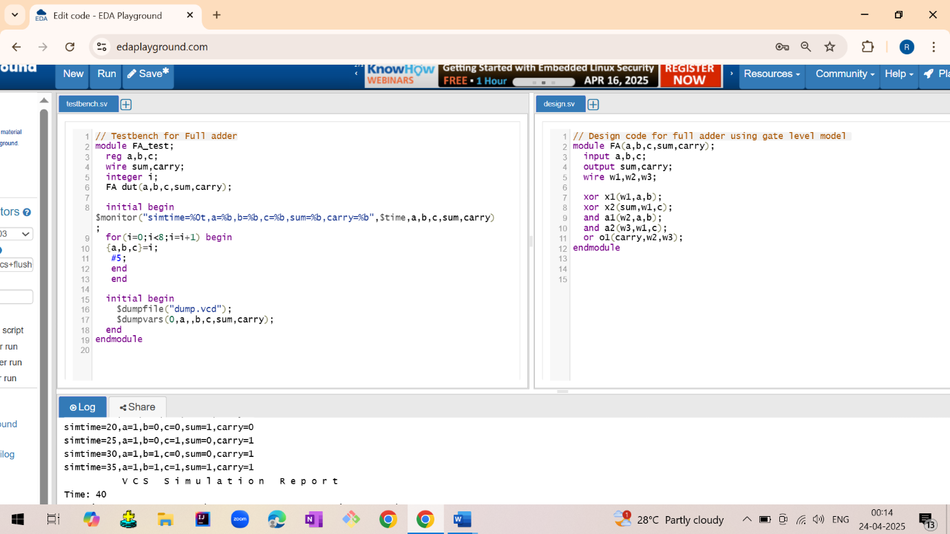

Output:

Sim time=0,a=0,b=0,c=0,sum=0,carry=0  
 sim time=5,a=0,b=0,c=1,sum=1,carry=0  
 sim time=10,a=0,b=1,c=0,sum=1,carry=0  
 sim time=15,a=0,b=1,c=1,sum=0,carry=1  
 sim time=20,a=1,b=0,c=0,sum=1,carry=0  
 sim time=25,a=1,b=0,c=1,sum=0,carry=1  
 sim time=30,a=1,b=1,c=0,sum=0,carry=1  
 sim time=35,a=1,b=1,c=1,sum=1,carry=1

Waveform: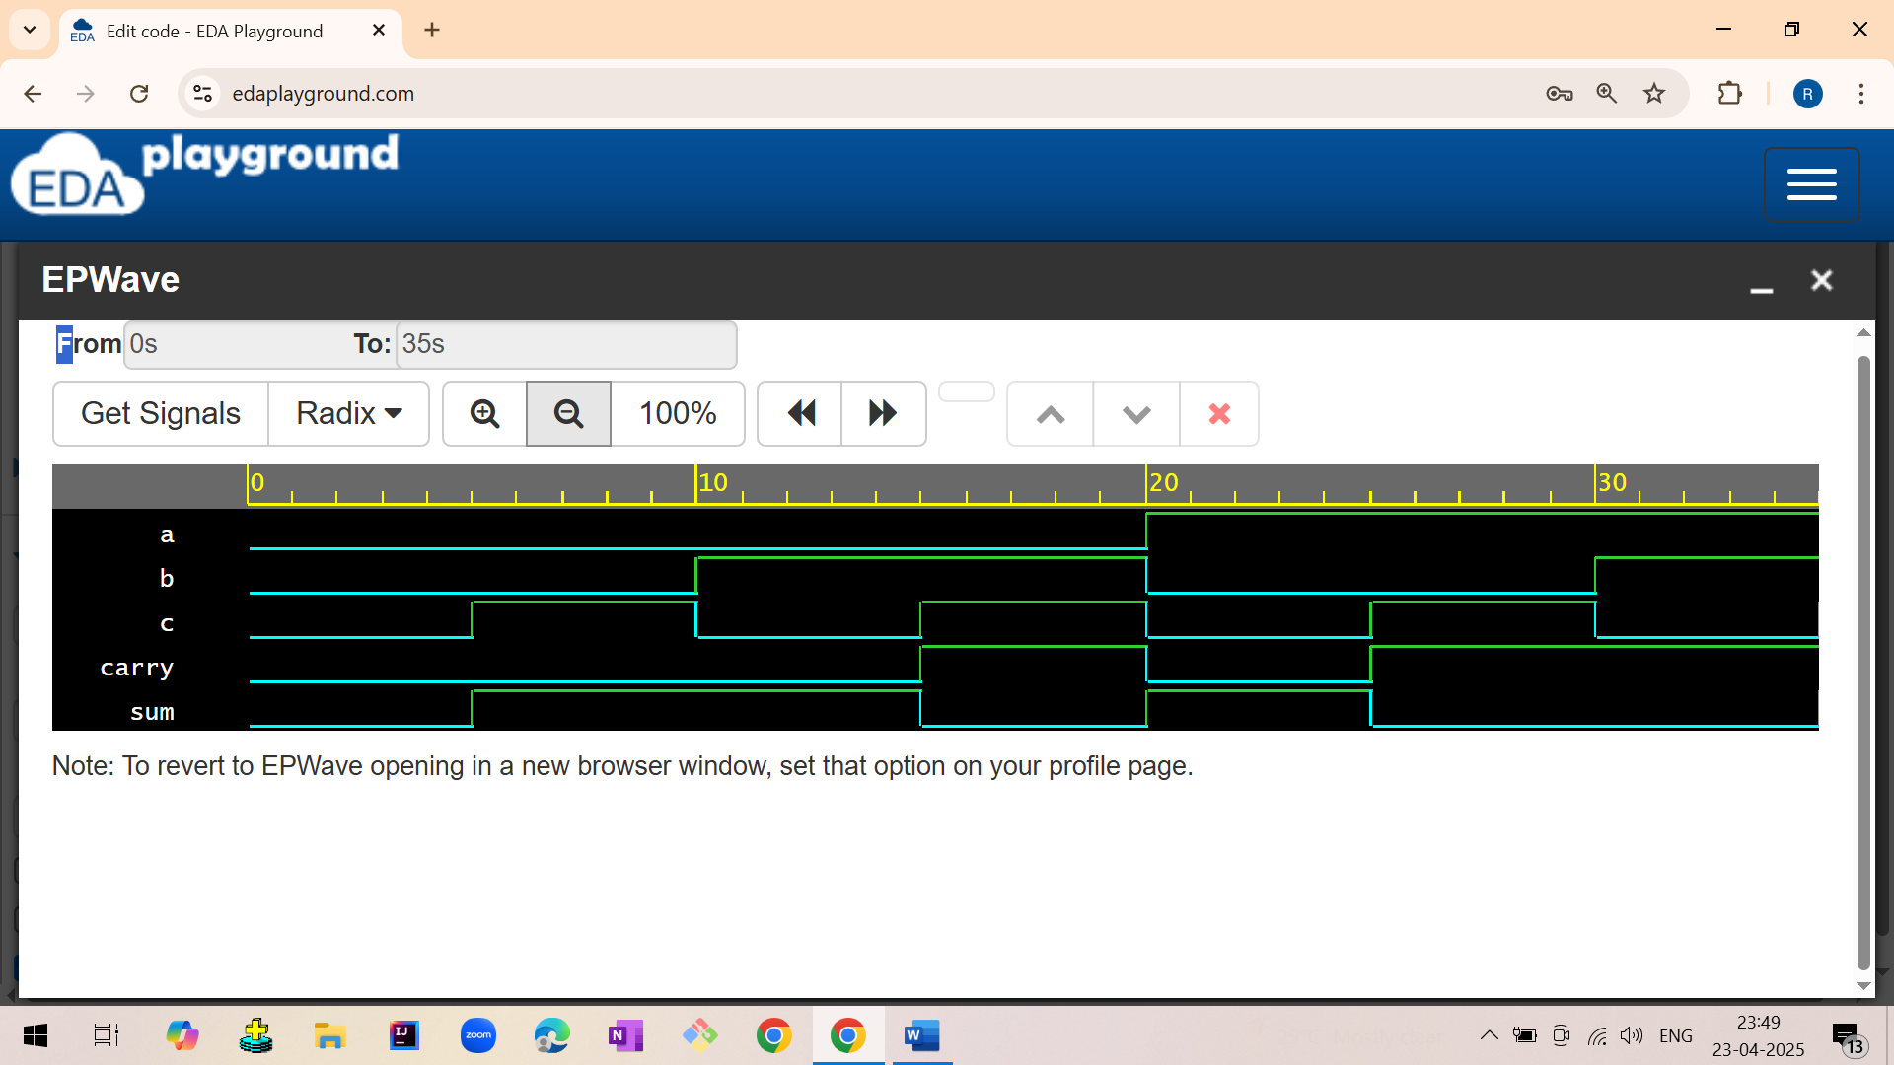

2. ADDER

2.1 Half Adder

2.1.1 Half adder using data flow model

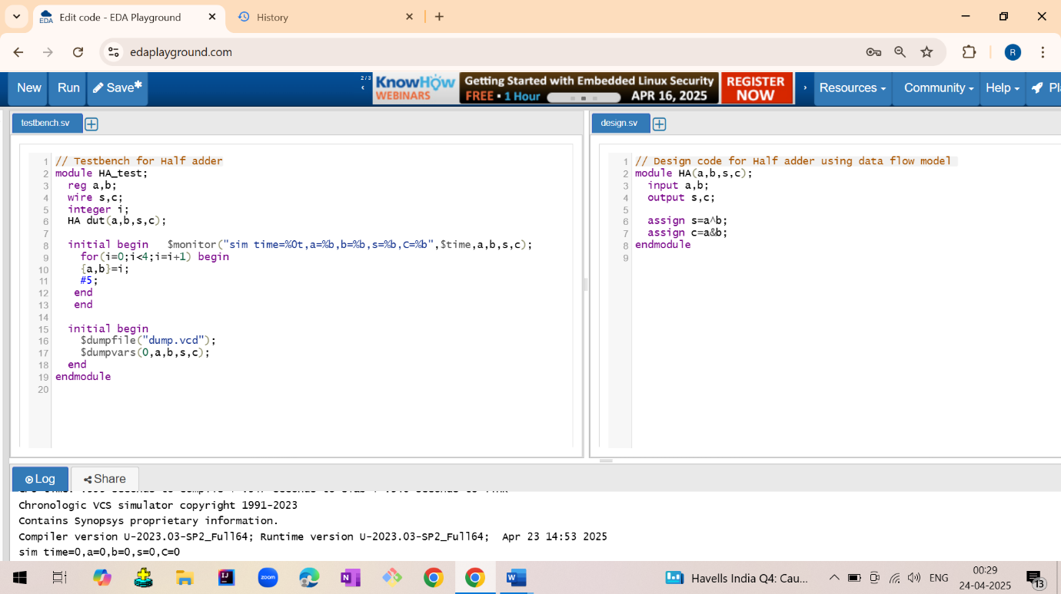

2.1.2 Half adder using gate level model

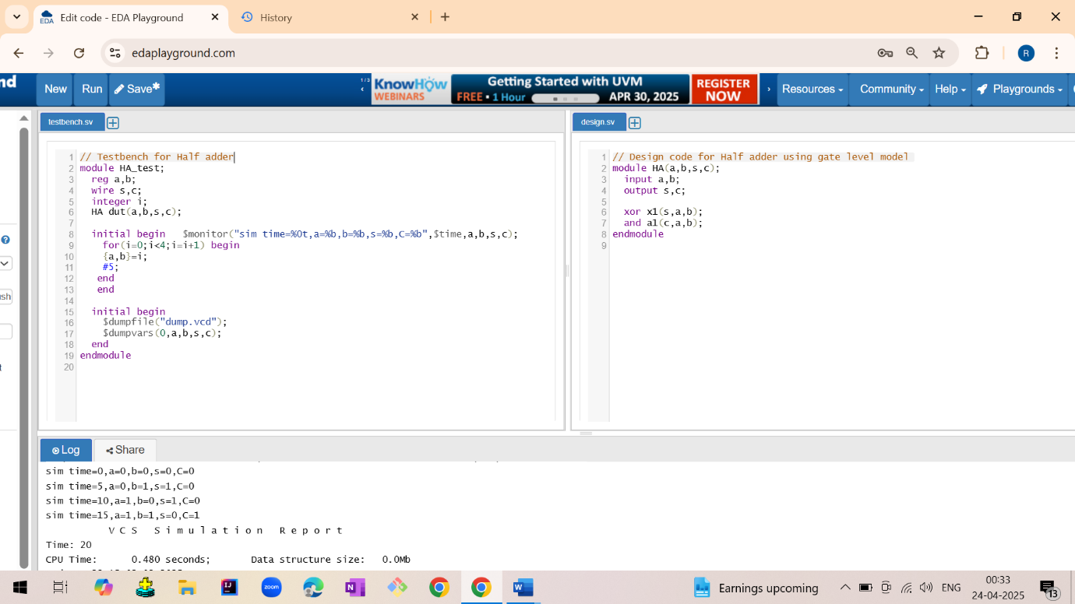

2.1.3 Half adder using behavioral model

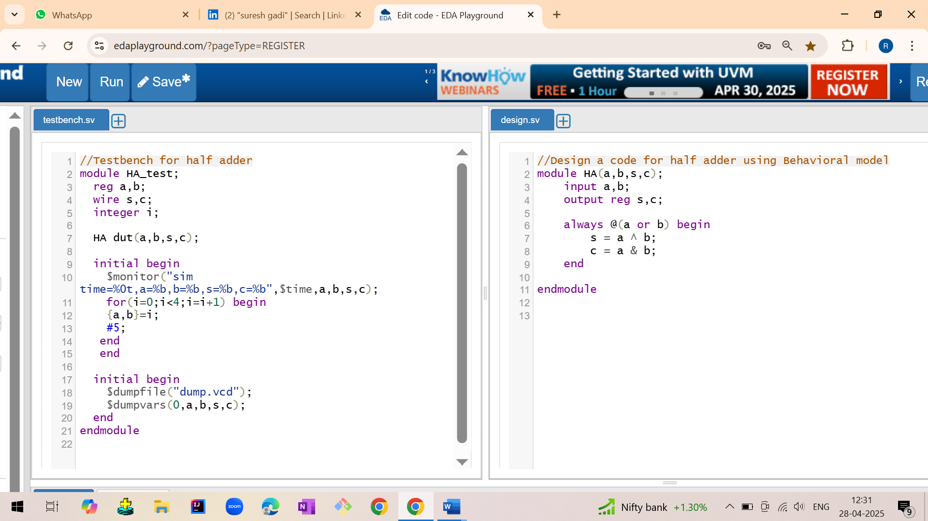

Output:

sim time=0,a=0,b=0,s=0,C=0  
 sim time=5,a=0,b=1,s=1,C=0  
 sim time=10,a=1,b=0,s=1,C=0  
 sim time=15,a=1,b=1,s=0,C=1

Waveform:

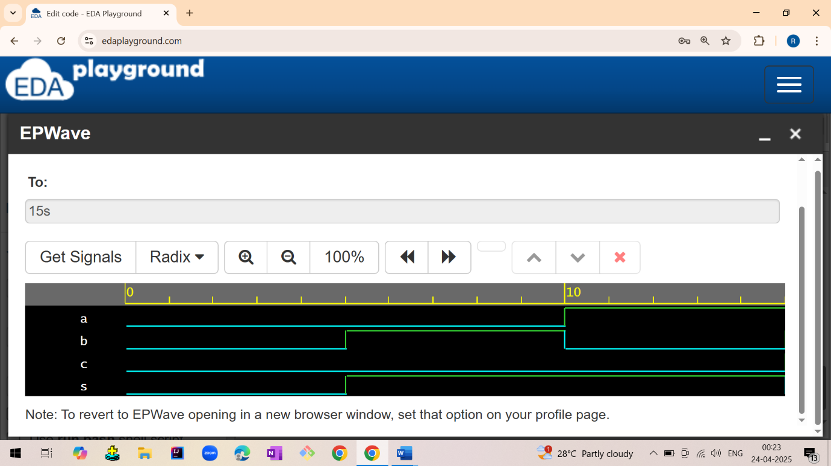

1. LOGIC GATES

1.1 AND GATE

1.1.1 And gate using data flow model

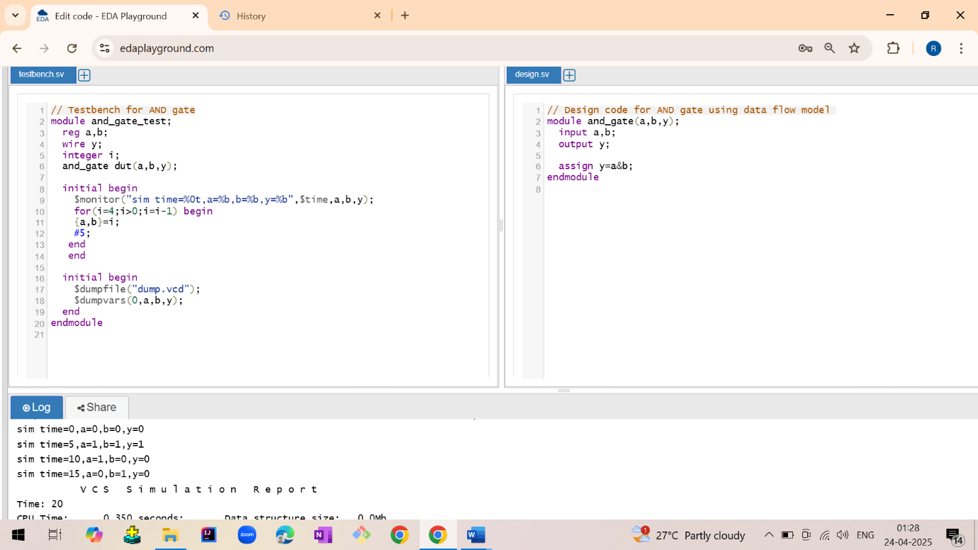

1.1.2 And gate using gate level model

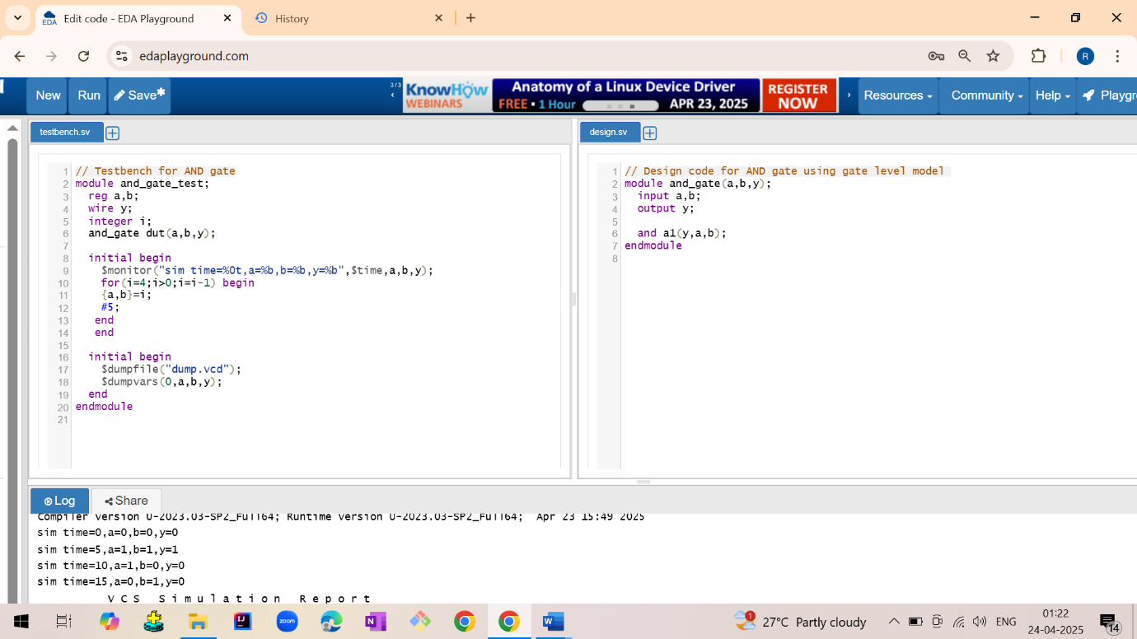

Output:

sim time=0,a=0,b=0,y=0  
 sim time=5,a=1,b=1,y=1  
 sim time=10,a=1,b=0,y=0  
 sim time=15,a=0,b=1,y=0

Waveform:

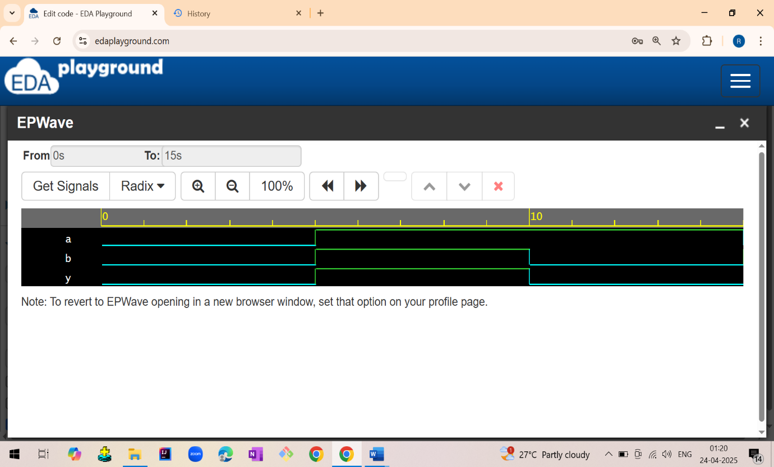

1.2 OR GATE

1.2.1 OR gate using data flow model

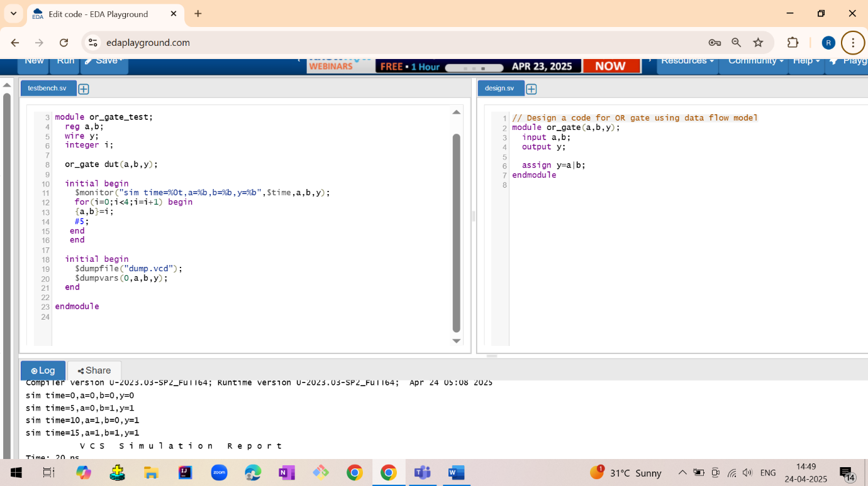

1.2.2 OR gate using gate level model

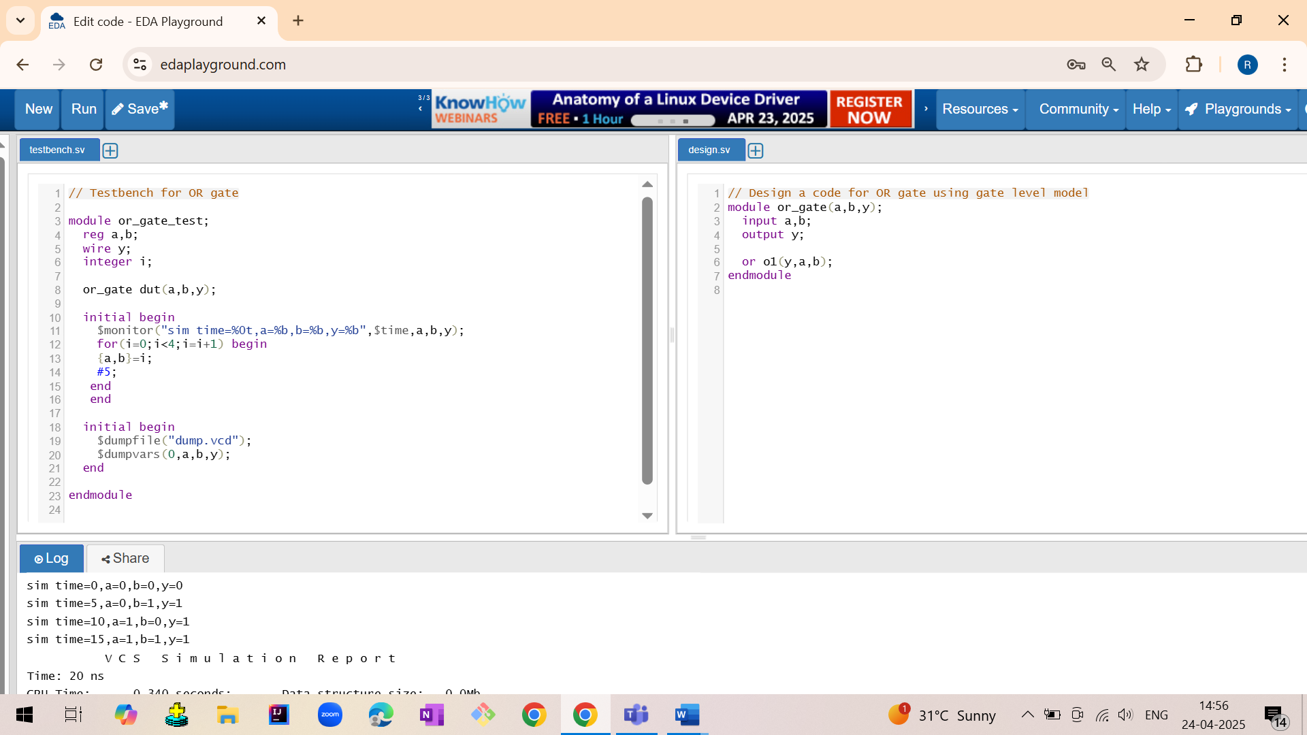

Output:

sim time=0,a=0,b=0,y=0  
 sim time=5,a=0,b=1,y=1  
 sim time=10,a=1,b=0,y=1  
 sim time=15,a=1,b=1,y=1

Waveforms:

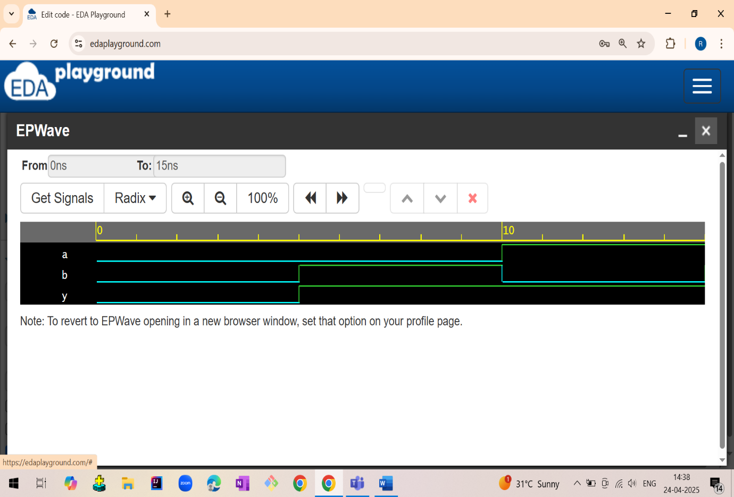

1.3 NOT GATE

1.3.1 NOT gate using data flow model

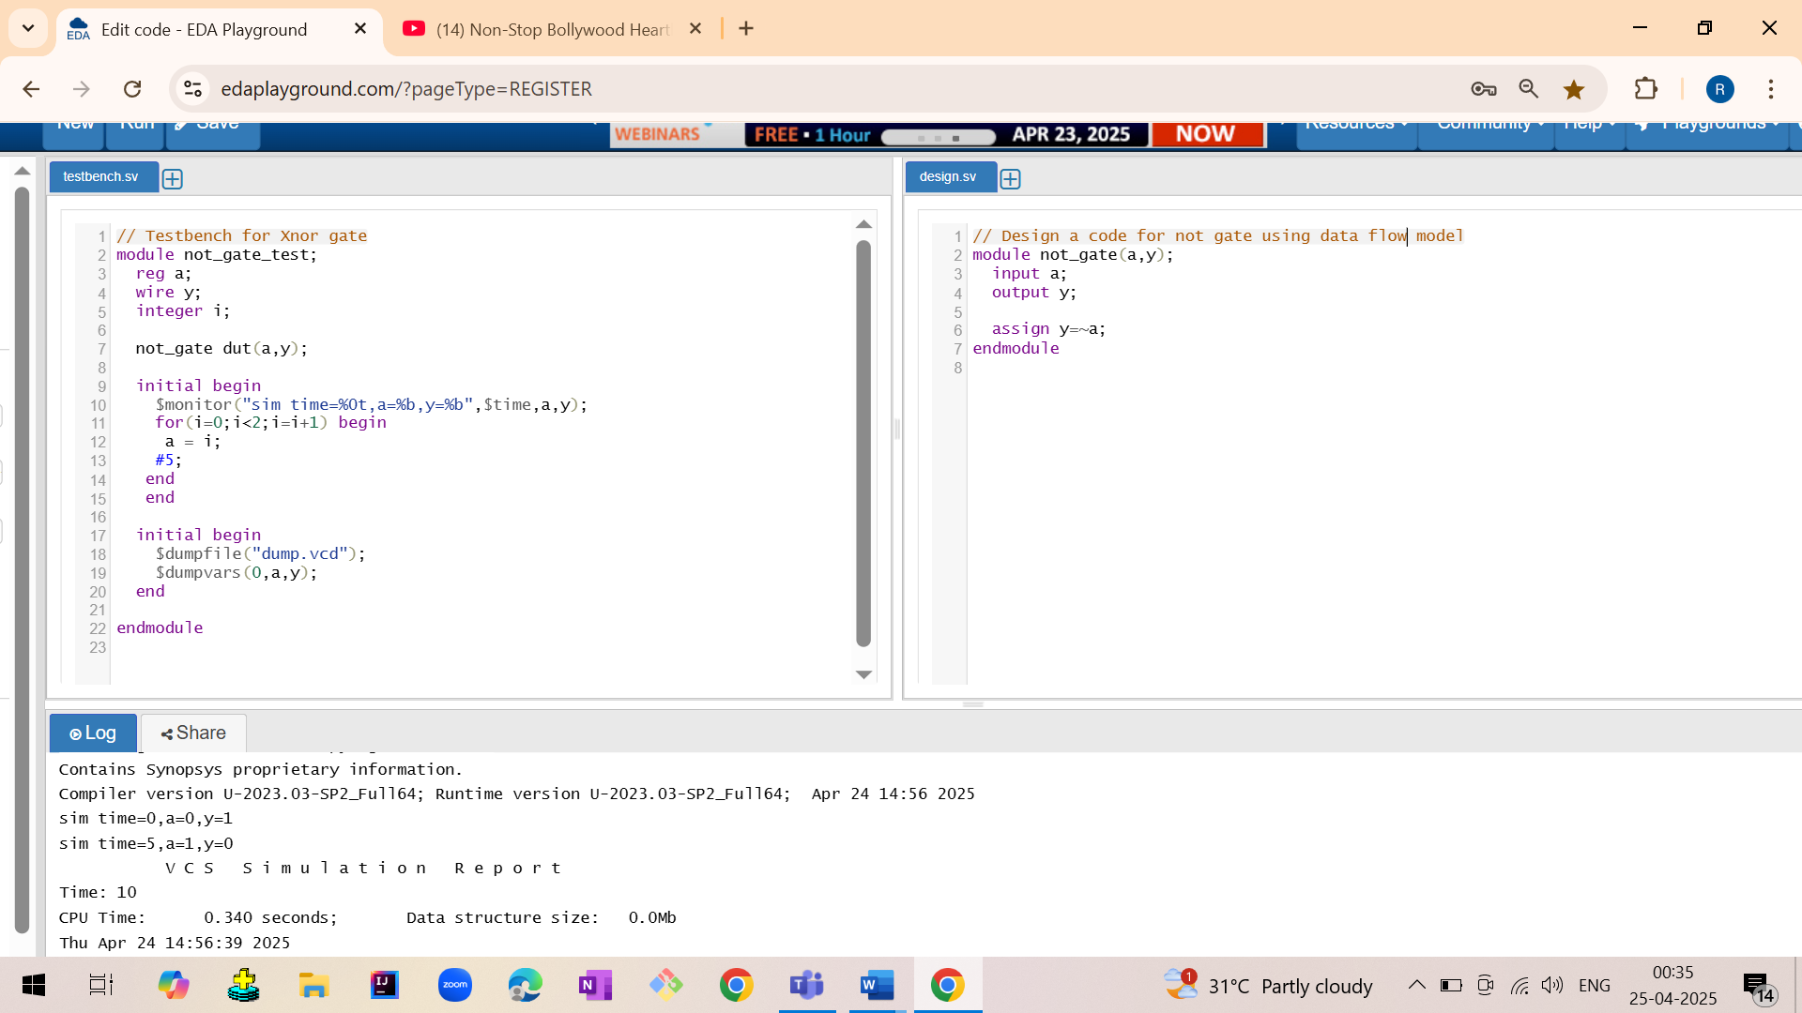

1.3.2 NOT gate using gate level model

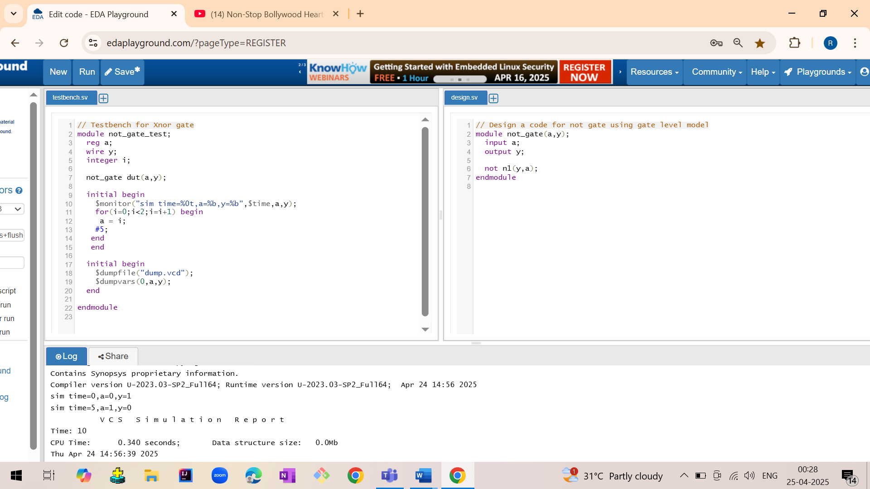

Output:

sim time=0,a=0,y=1  
 sim time=5,a=1,y=0

Waveform:

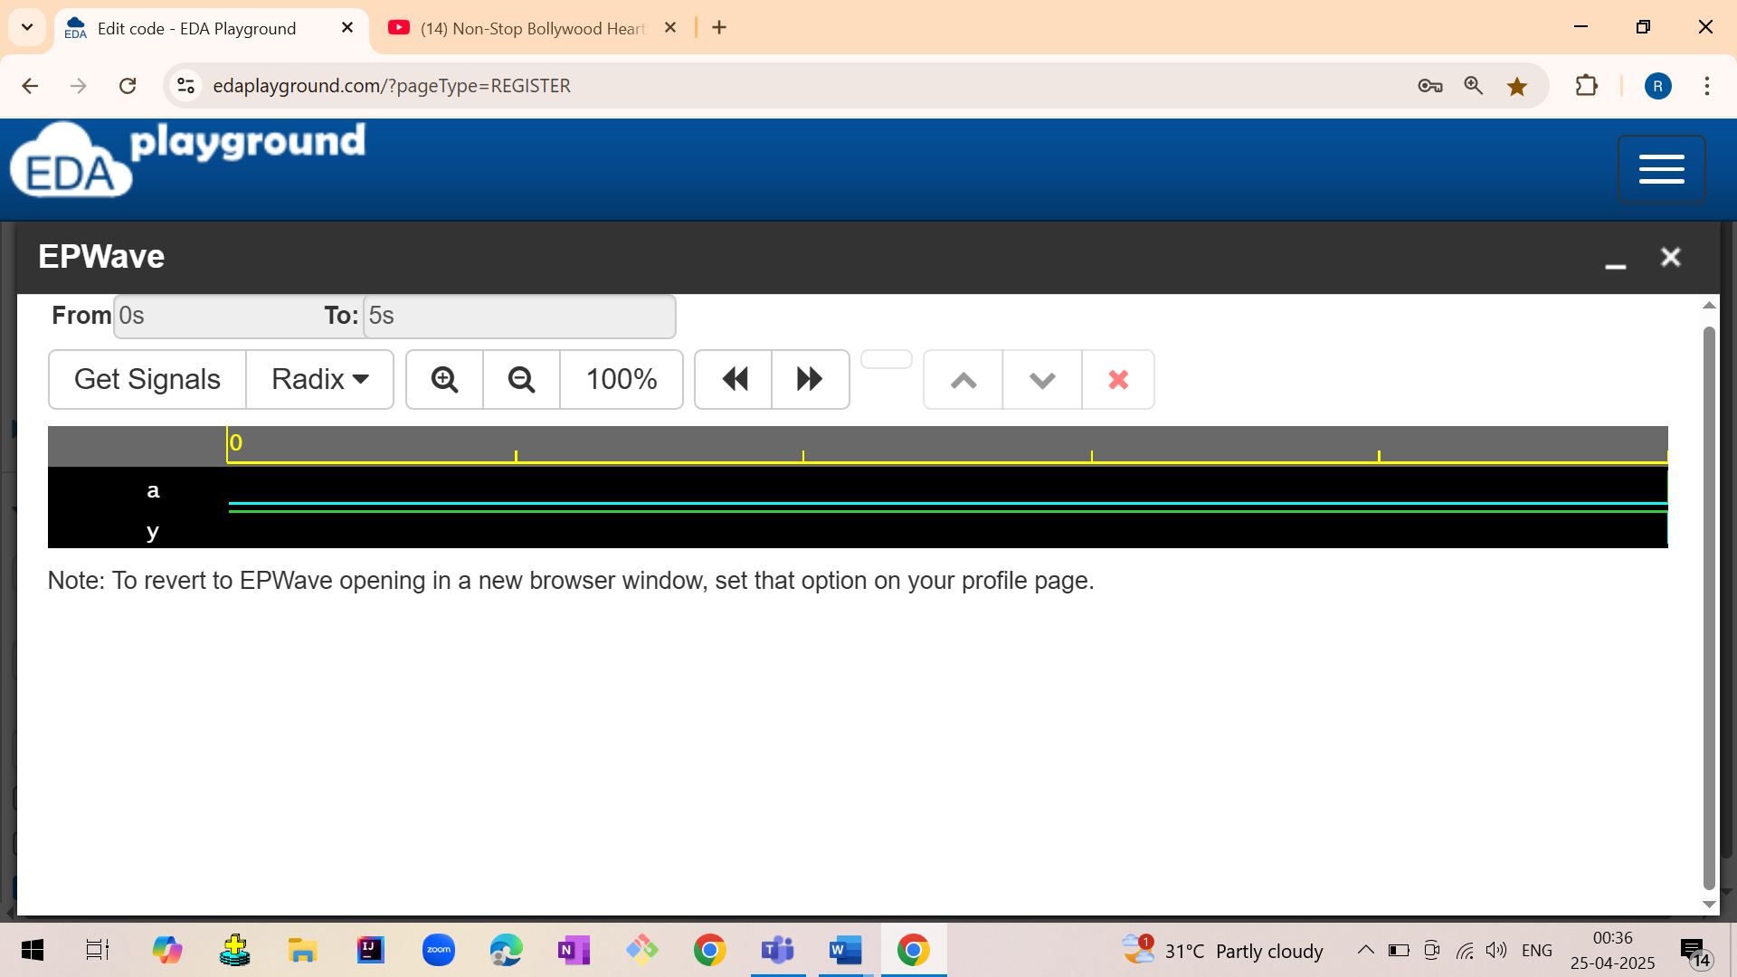

1.4 NAND GATE

1.4.1 NAND gate using data flow model

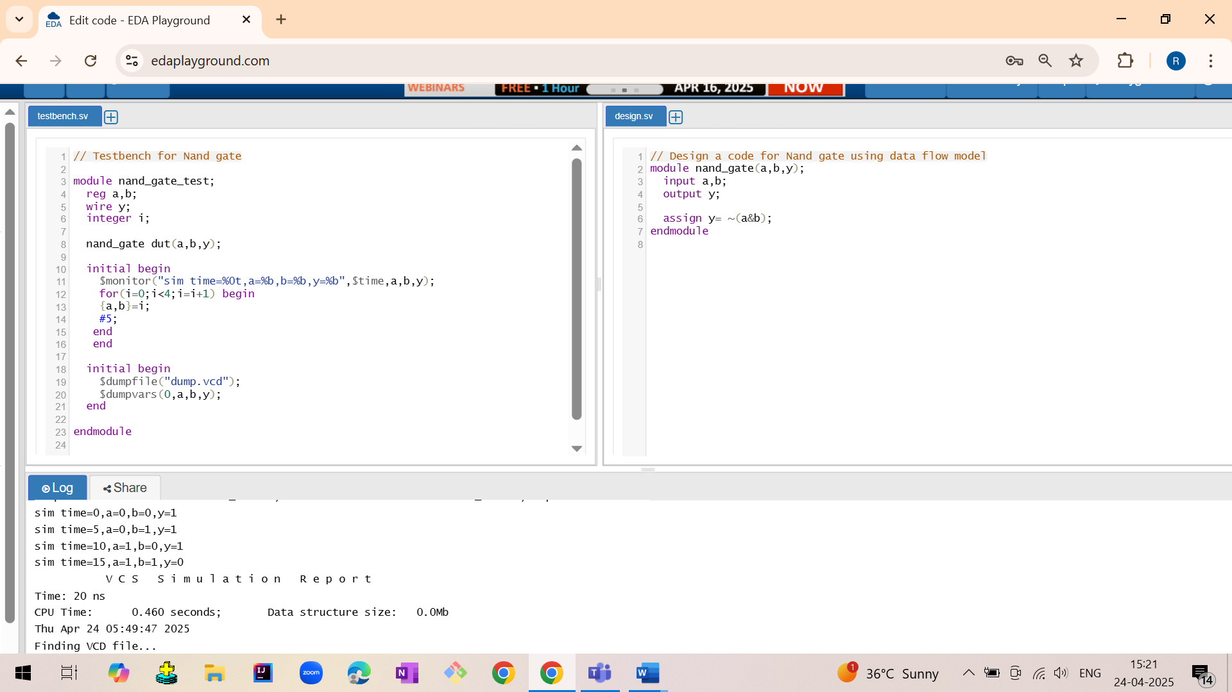

1.4.2 NAND gate using gate level model

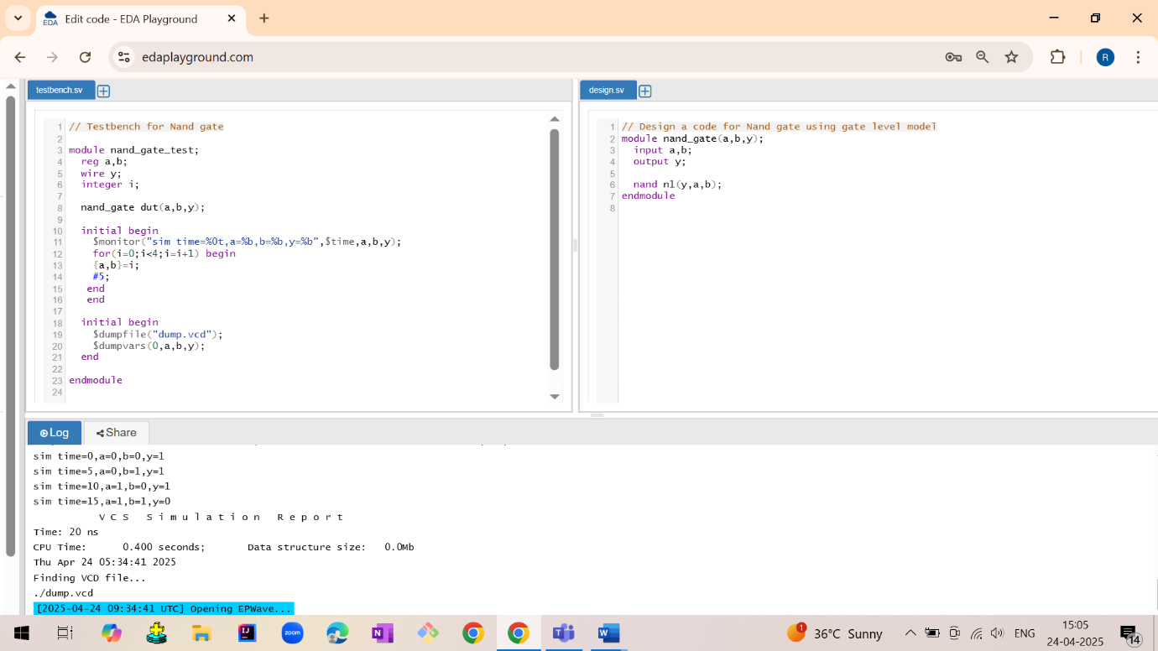

Output:

sim time=0,a=0,b=0,y=1  
 sim time=5,a=0,b=1,y=1  
 sim time=10,a=1,b=0,y=1  
 sim time=15,a=1,b=1,y=0

Waveforms:

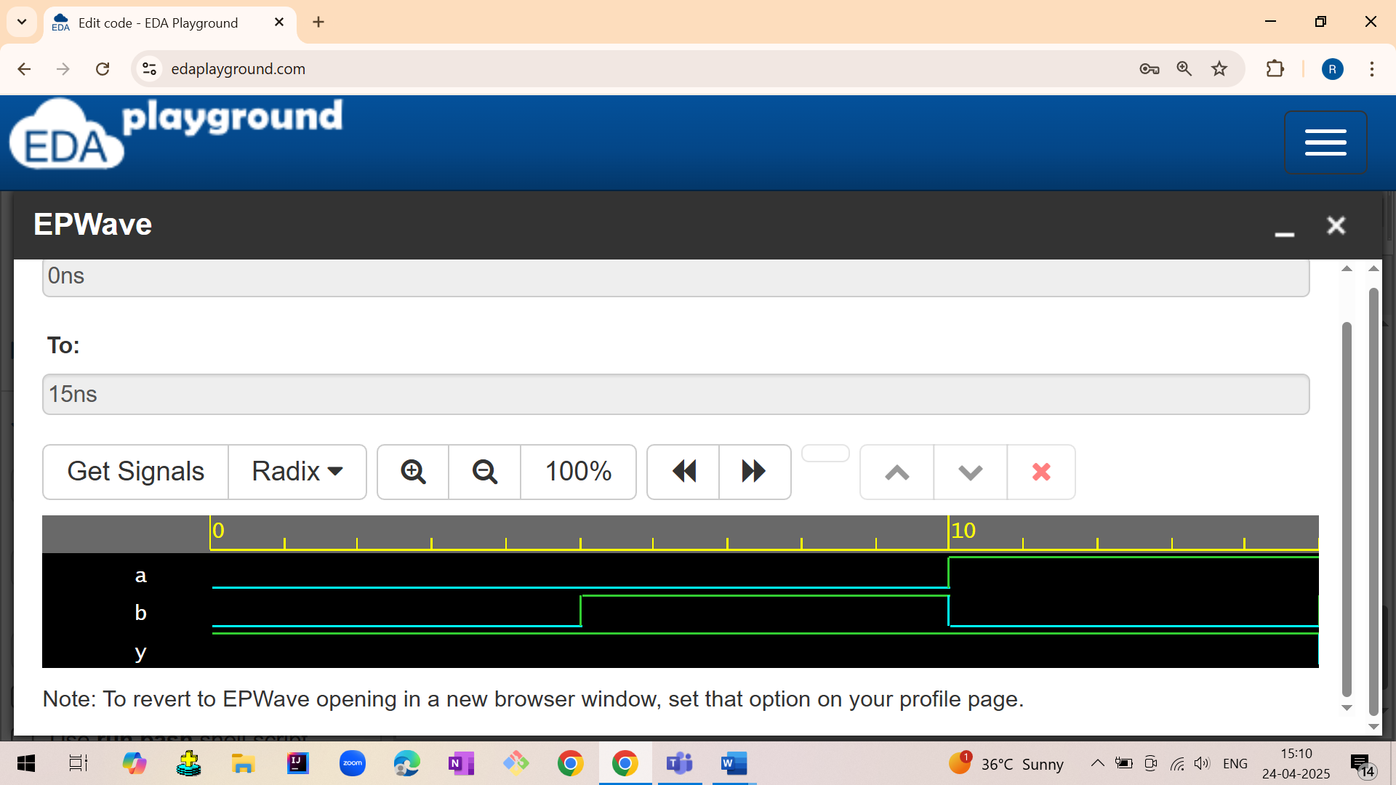

1.5 NOR GATE

1.5.1 NOR gate using data flow model

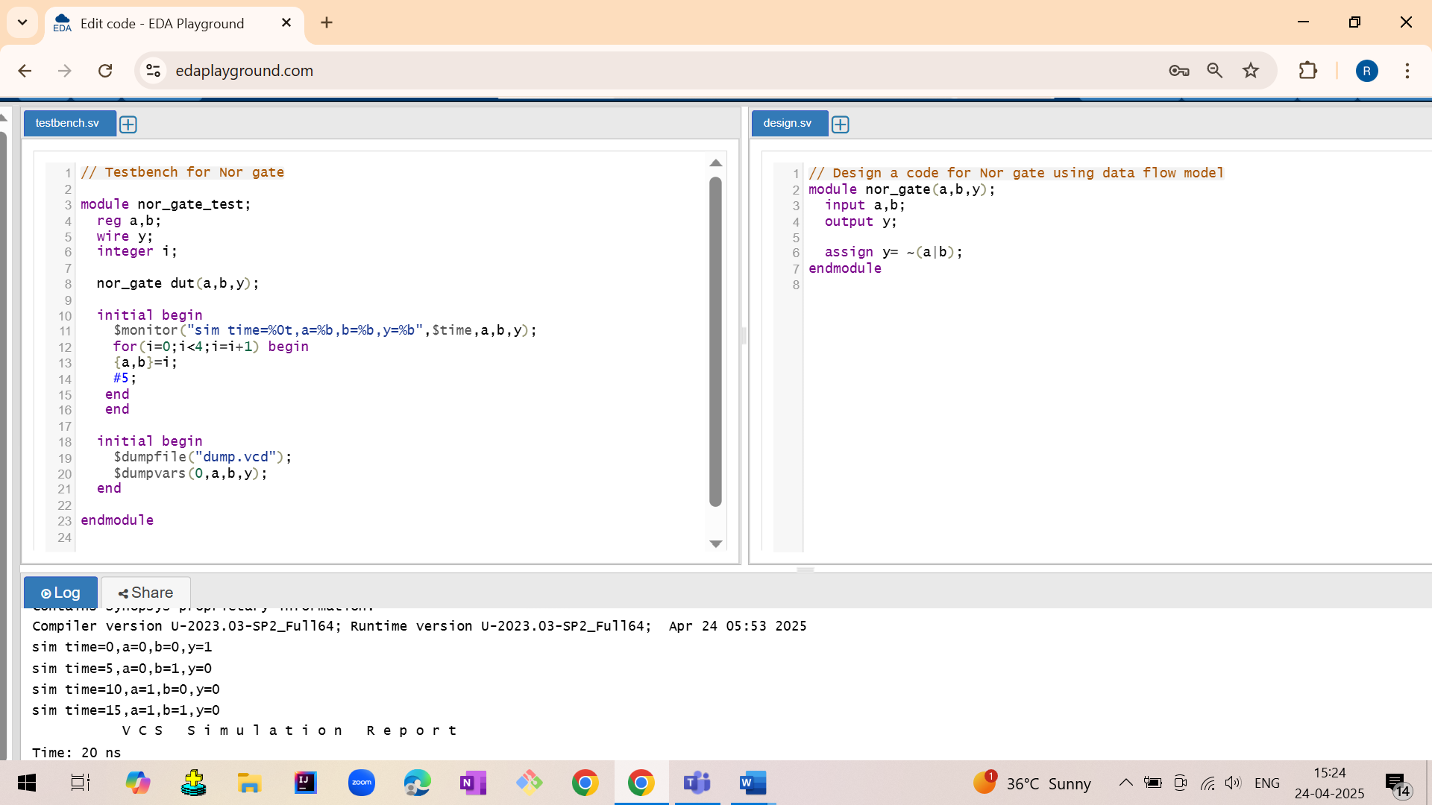

1.5.2 NOR gate using gate level model

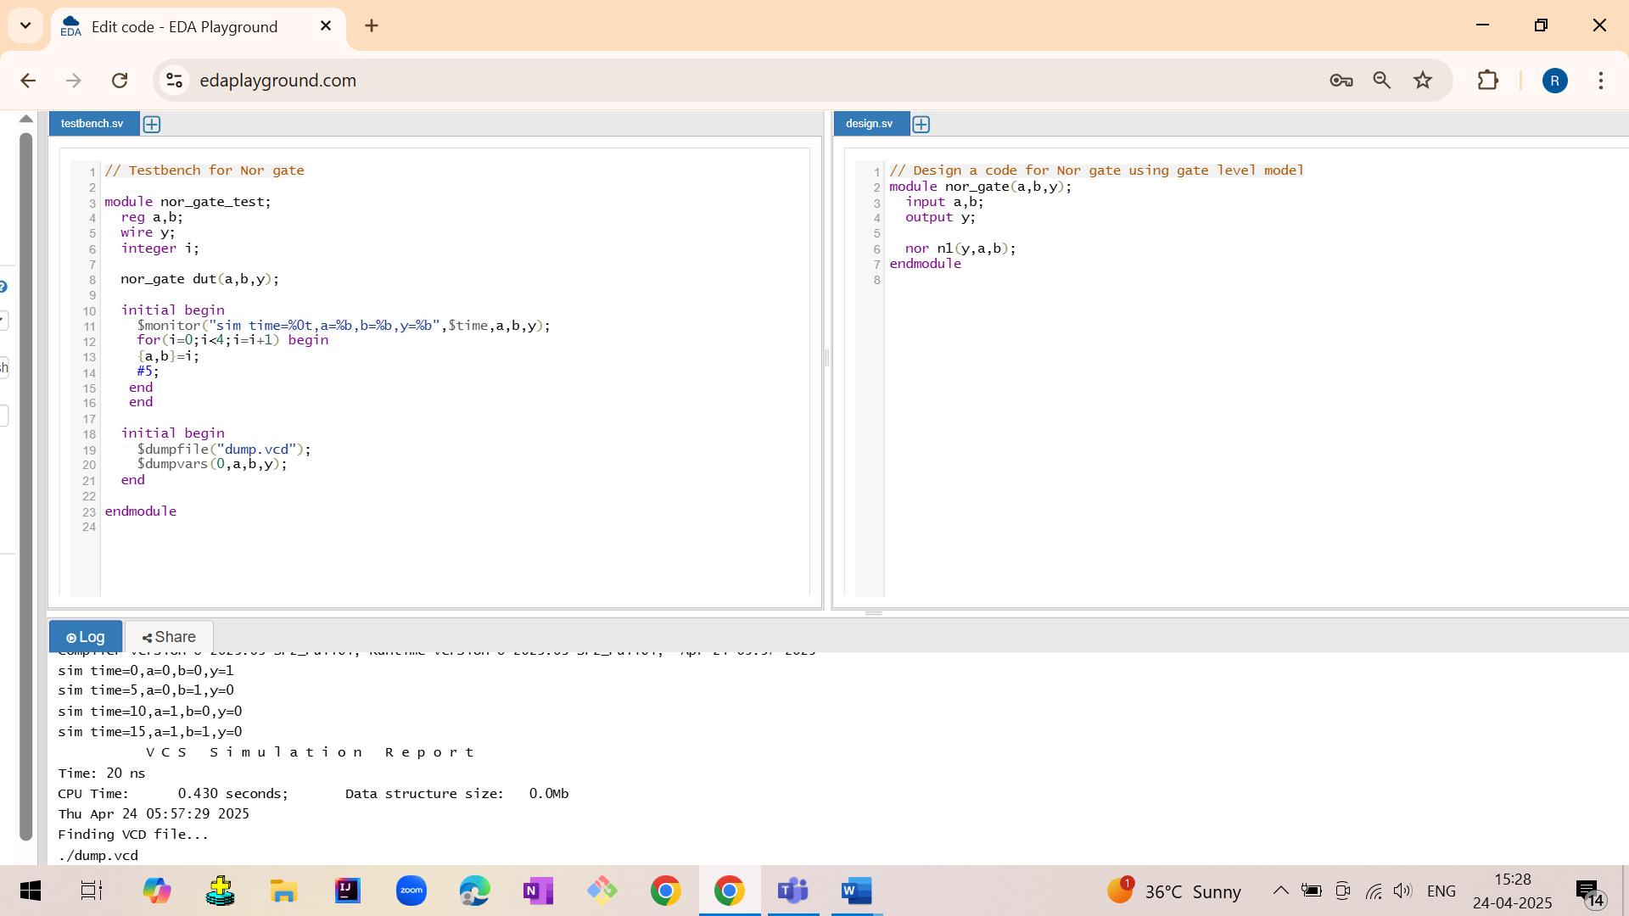

Output:

sim time=0,a=0,b=0,y=1  
 sim time=5,a=0,b=1,y=0  
 sim time=10,a=1,b=0,y=0  
 sim time=15,a=1,b=1,y=0

Waveforms:

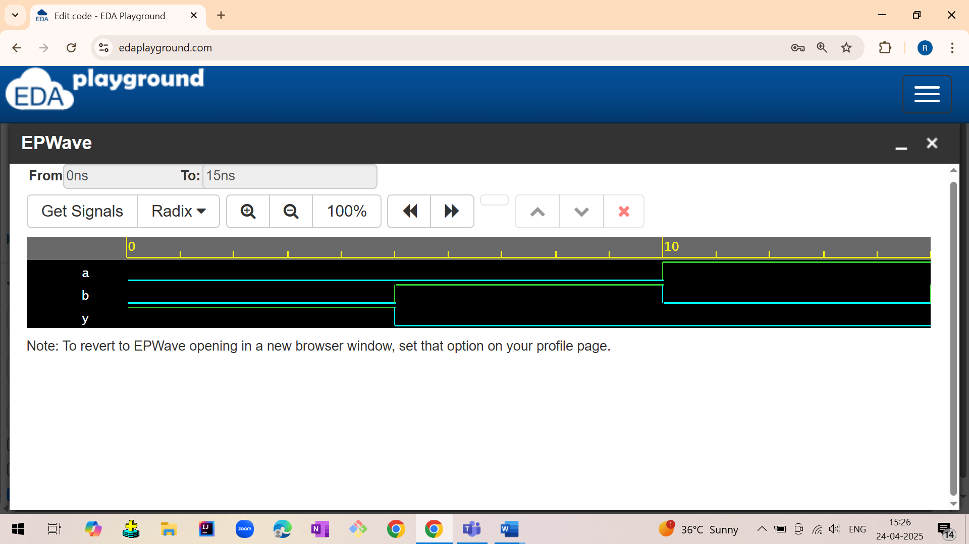

1.6 XOR GATE

1.6.1 NOR gate using data flow model

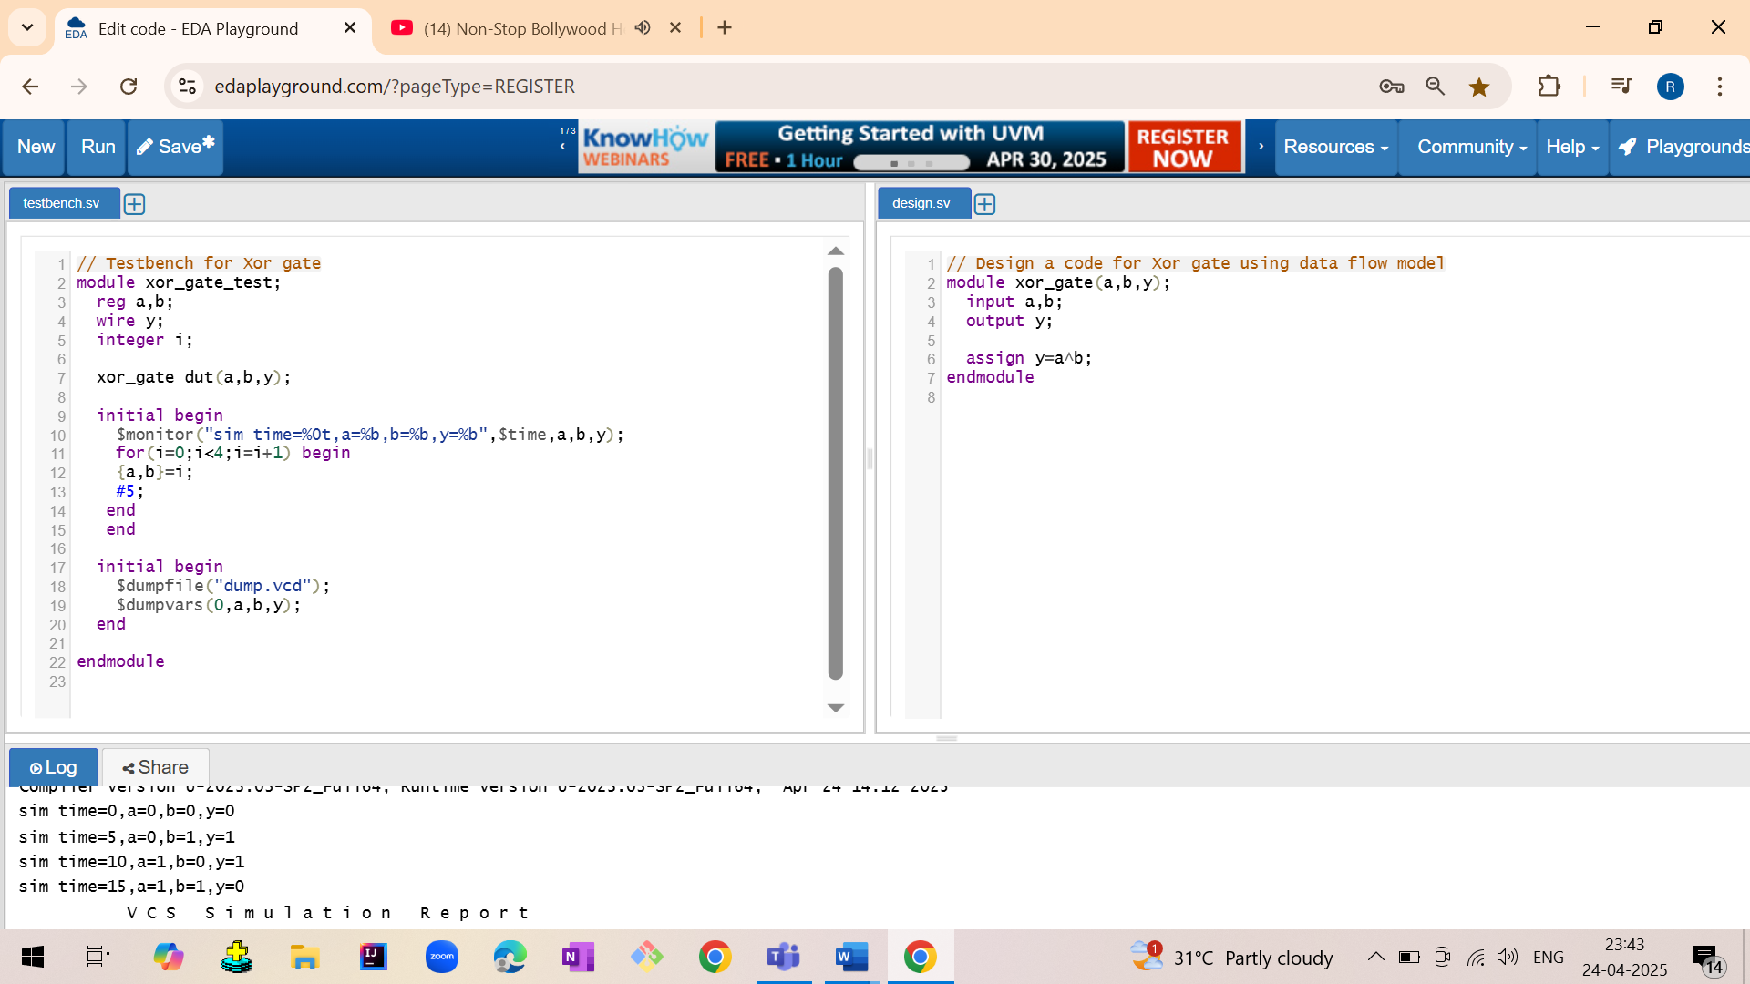

1.6.2 XOR gate using gate level model

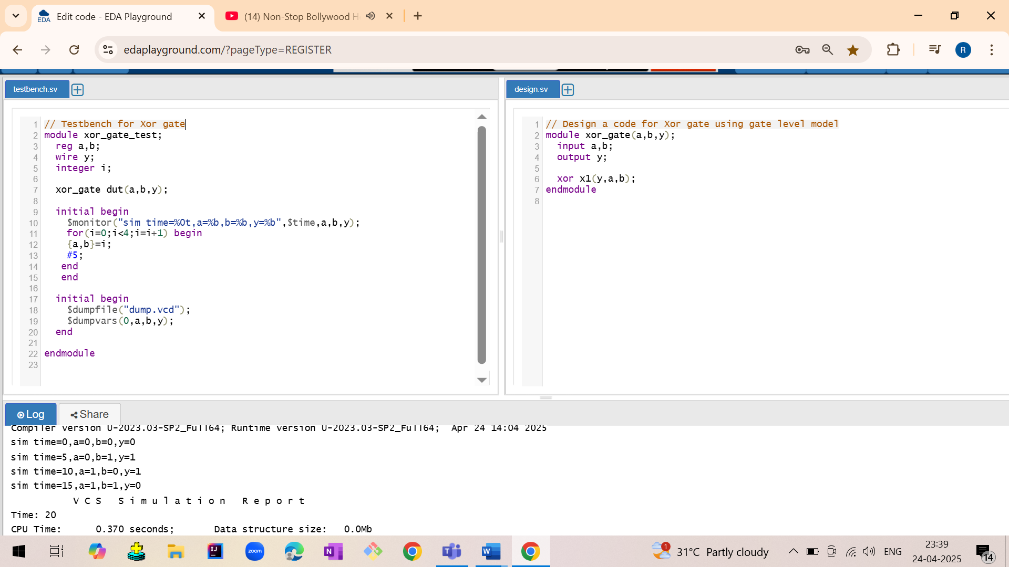

Output:

sim time=0,a=0,b=0,y=0  
 sim time=5,a=0,b=1,y=1  
 sim time=10,a=1,b=0,y=1  
 sim time=15,a=1,b=1,y=0

Waveforms:

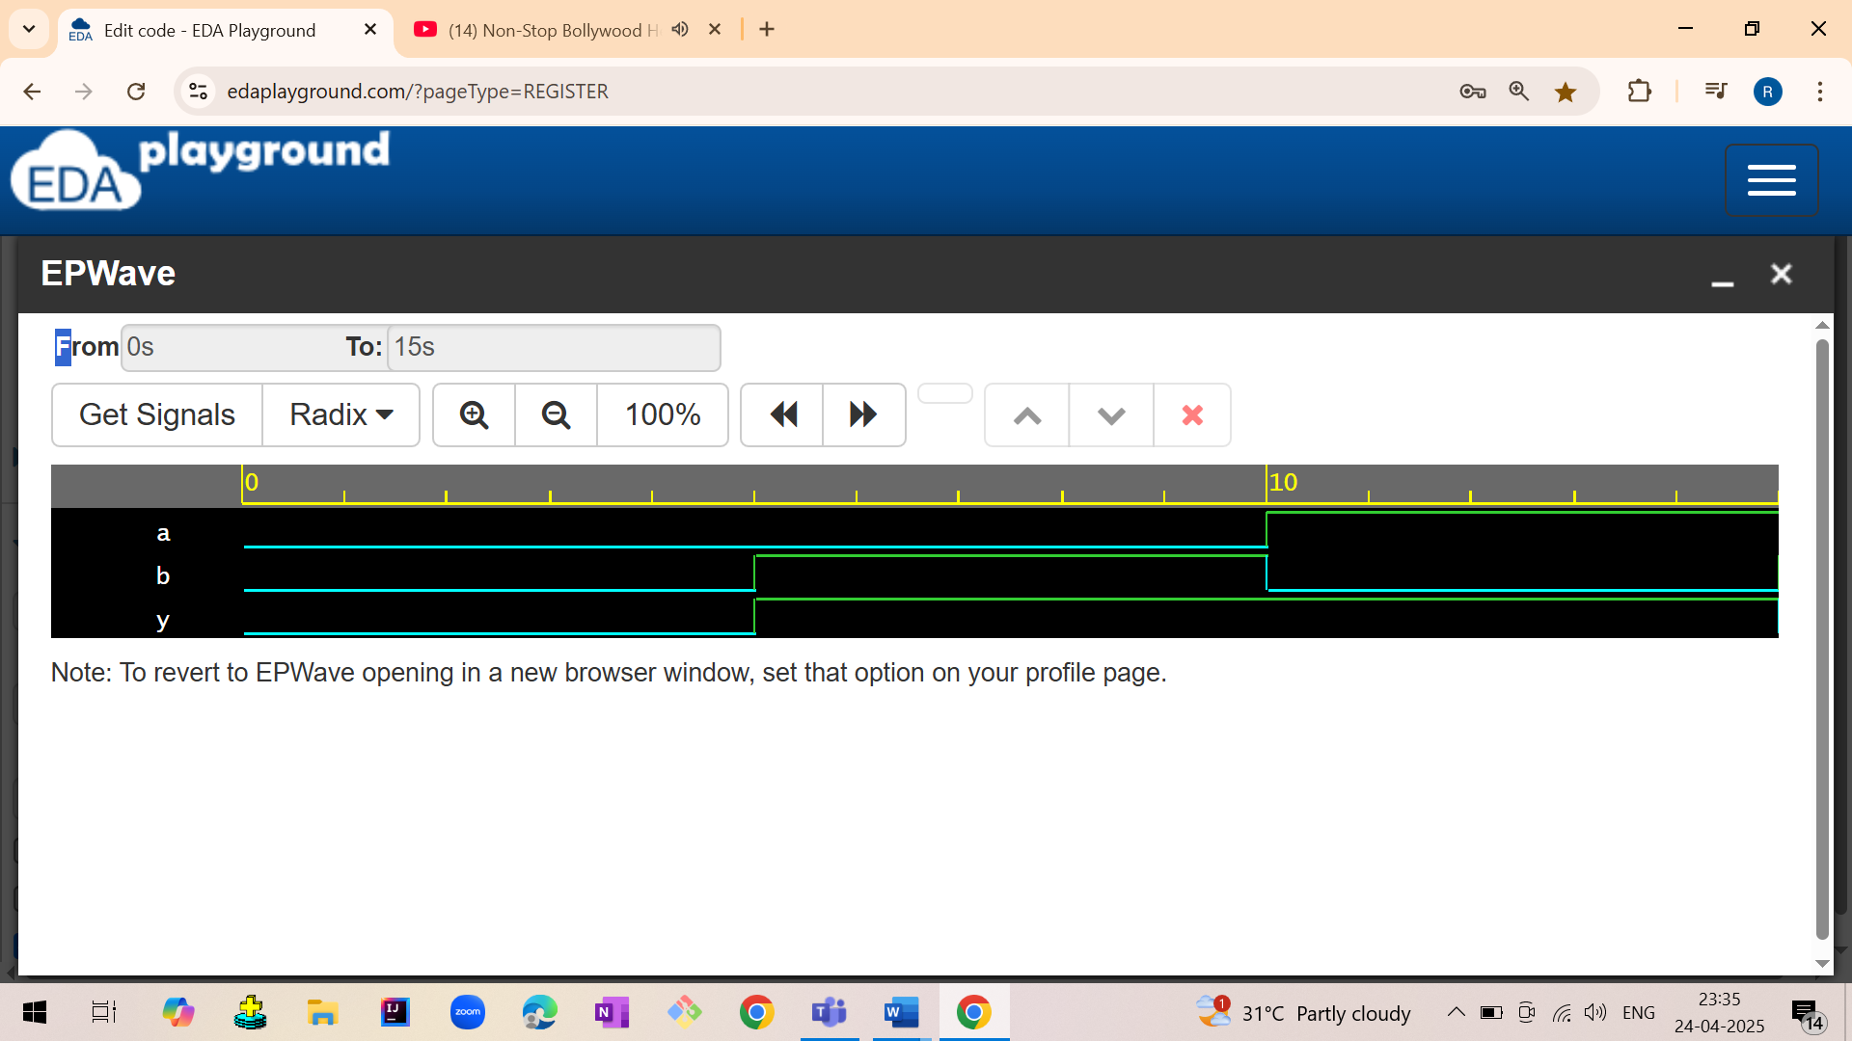

1.7 XNOR GATE

1.7.1 XNOR gate using data flow model

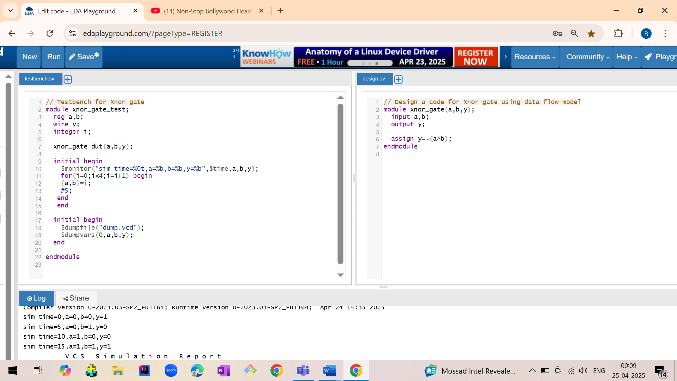

1.7.2 XNOR gate using gate level model

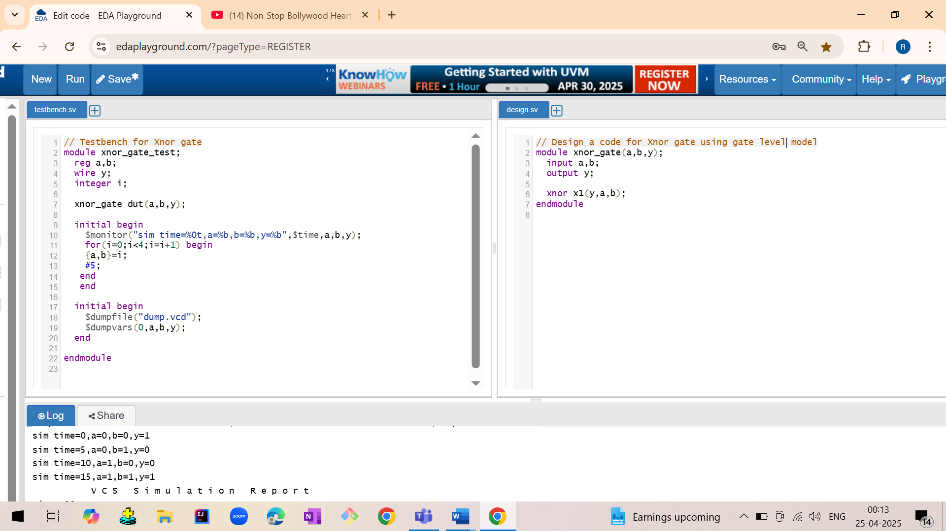

Output:

sim time=0,a=0,b=0,y=1  
 sim time=5,a=0,b=1,y=0  
 sim time=10,a=1,b=0,y=0  
 sim time=15,a=1,b=1,y=1

Waveform:

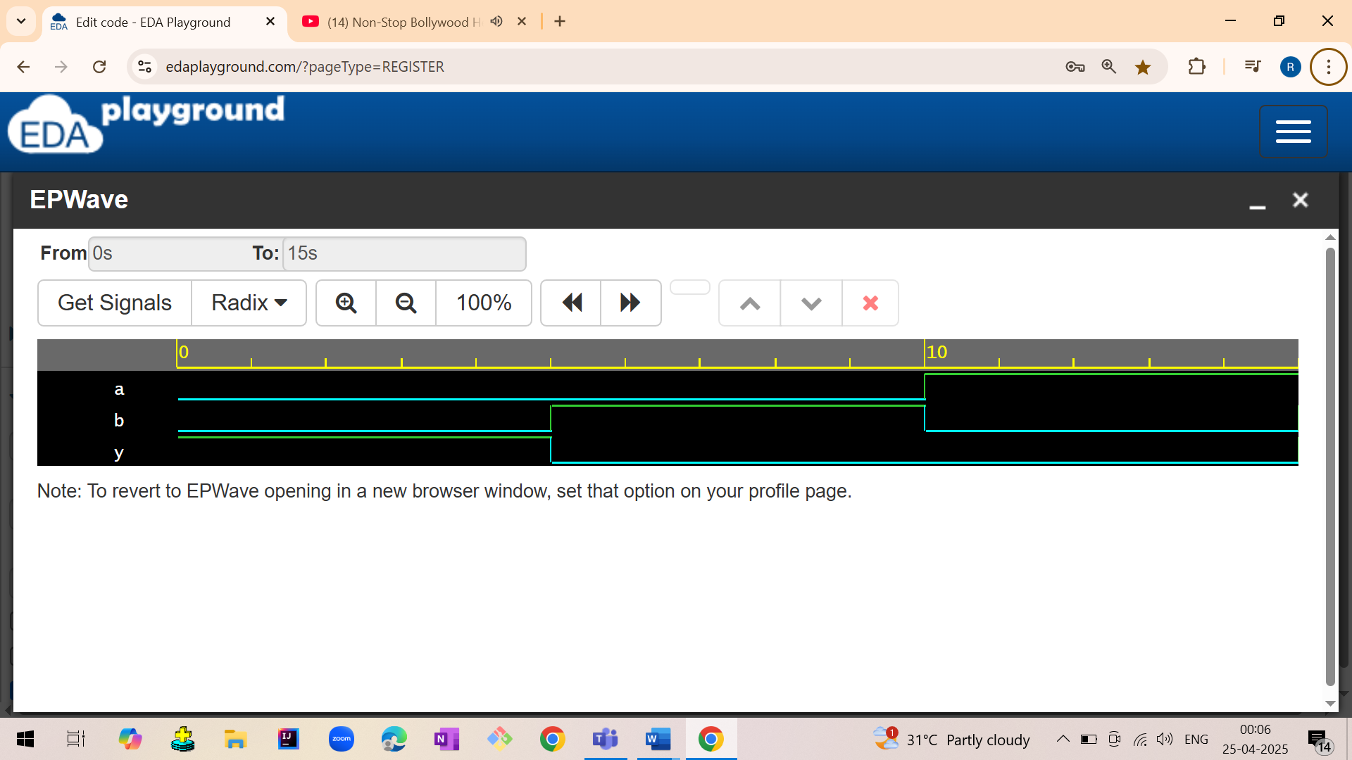

1.LOGIC GATES

1.1 LOGIC GATES USING GATE LEVEL MODEL

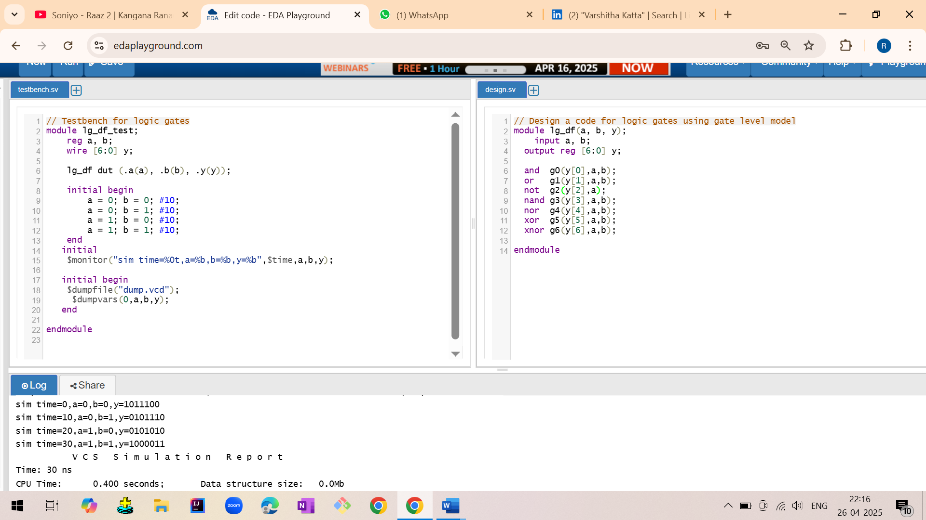

1.2 LOGIC GATES USING DATA FLOW MODEL

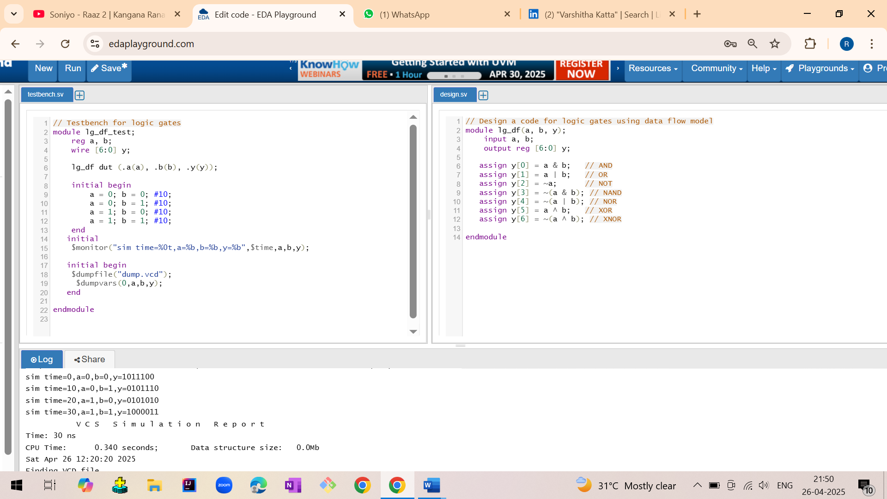

1.3 LOGIC GATES USING BEHAVIORAL MODE

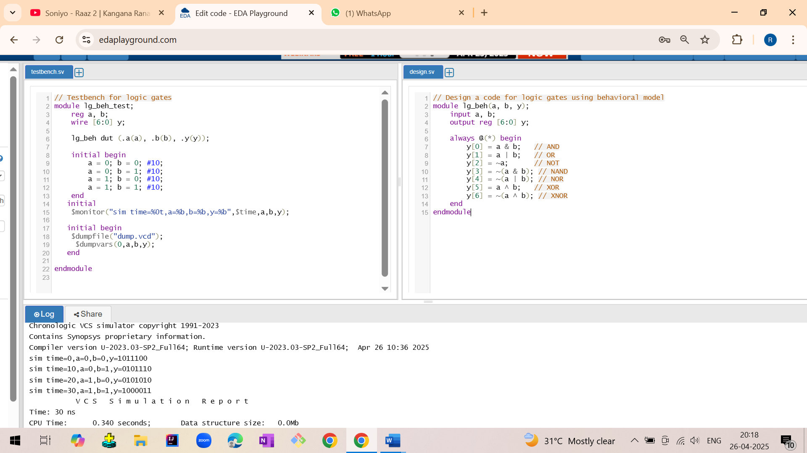

Output:

sim time=0 | a=0 | b=0 | y=1011100  
 sim time=10 | a=0 | b=1 | y=0101110  
 sim time=20 | a=1 | b=0 | y=0101010  
 sim time=30 | a=1 | b=1 | y=1000011

Waveform:

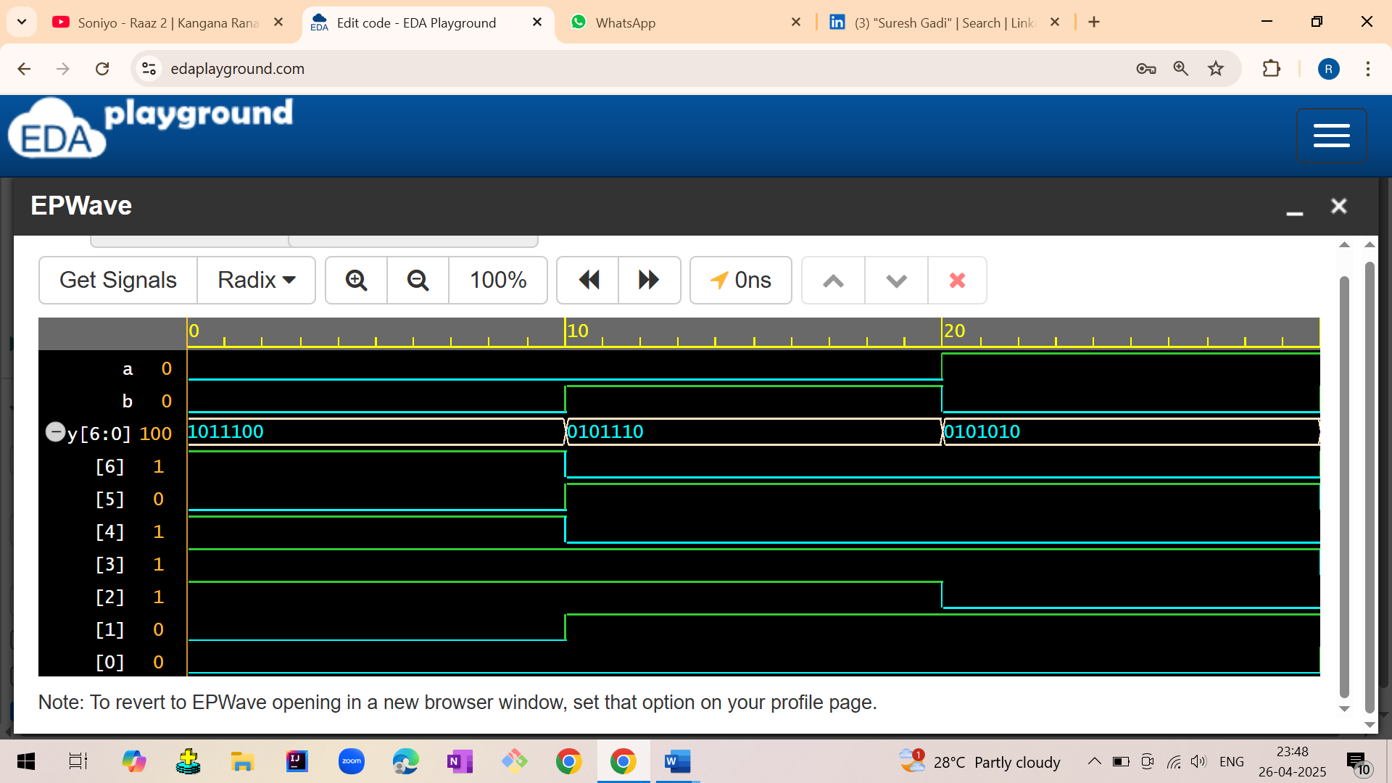

3.SUBTRACTOR

3.1 HALF SUBTRACTOR

3.1.1 Half subtractor using data flow model

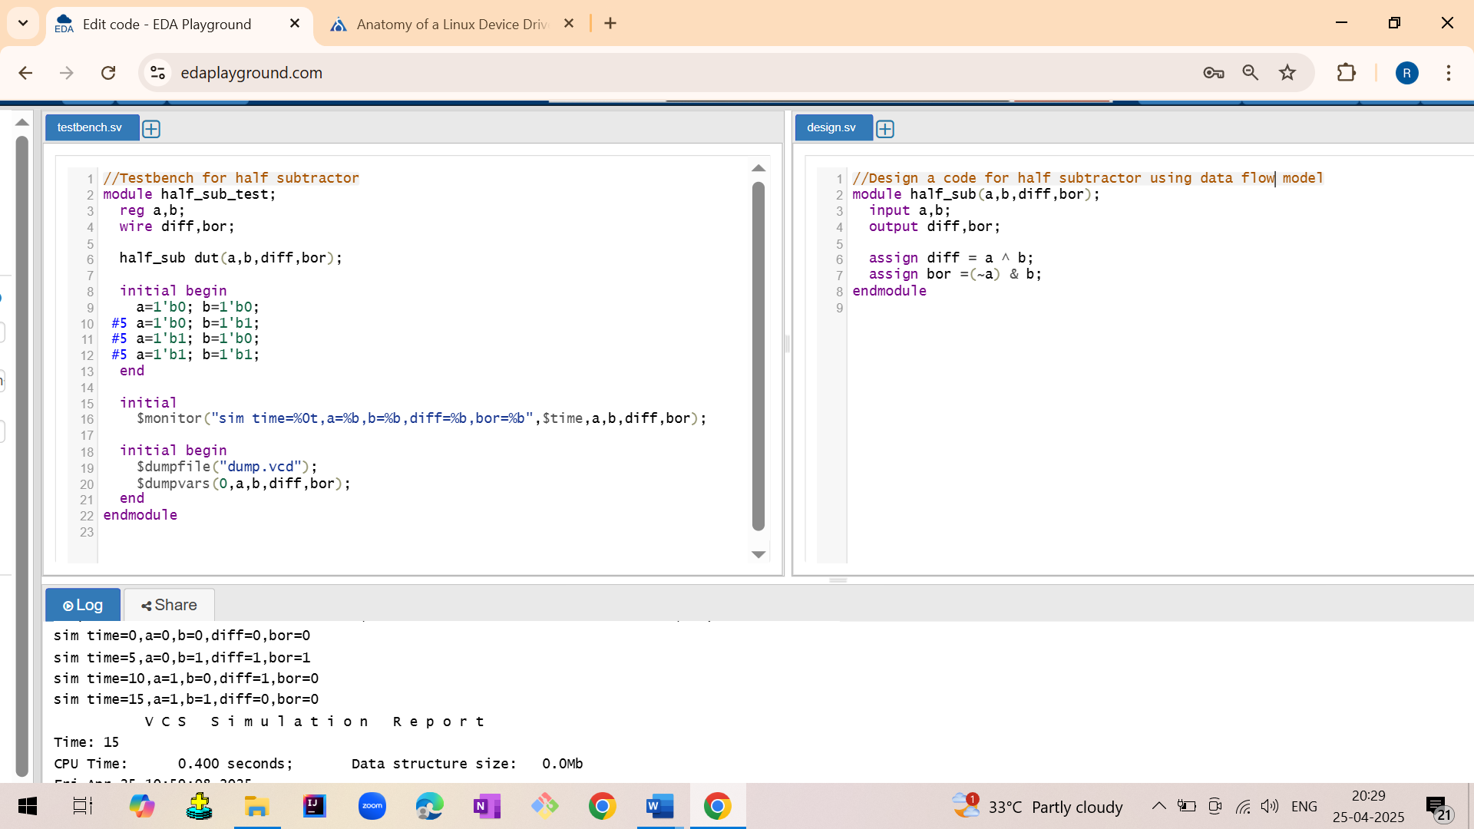

3.1.2 Half subtractor using gate level model

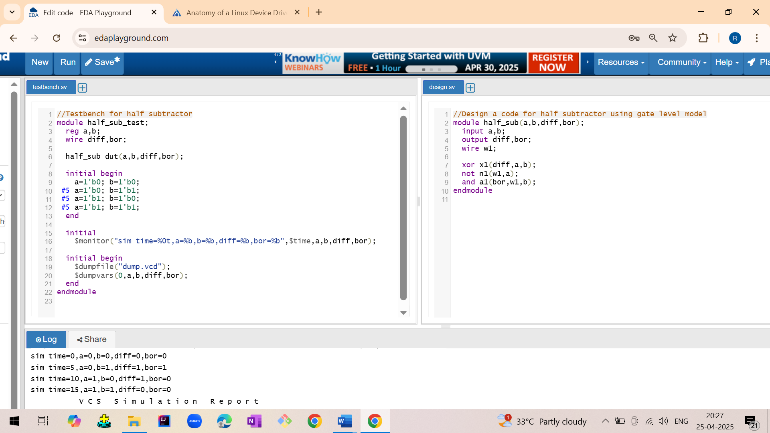

3.1.3 Half subtractor using behavioral model

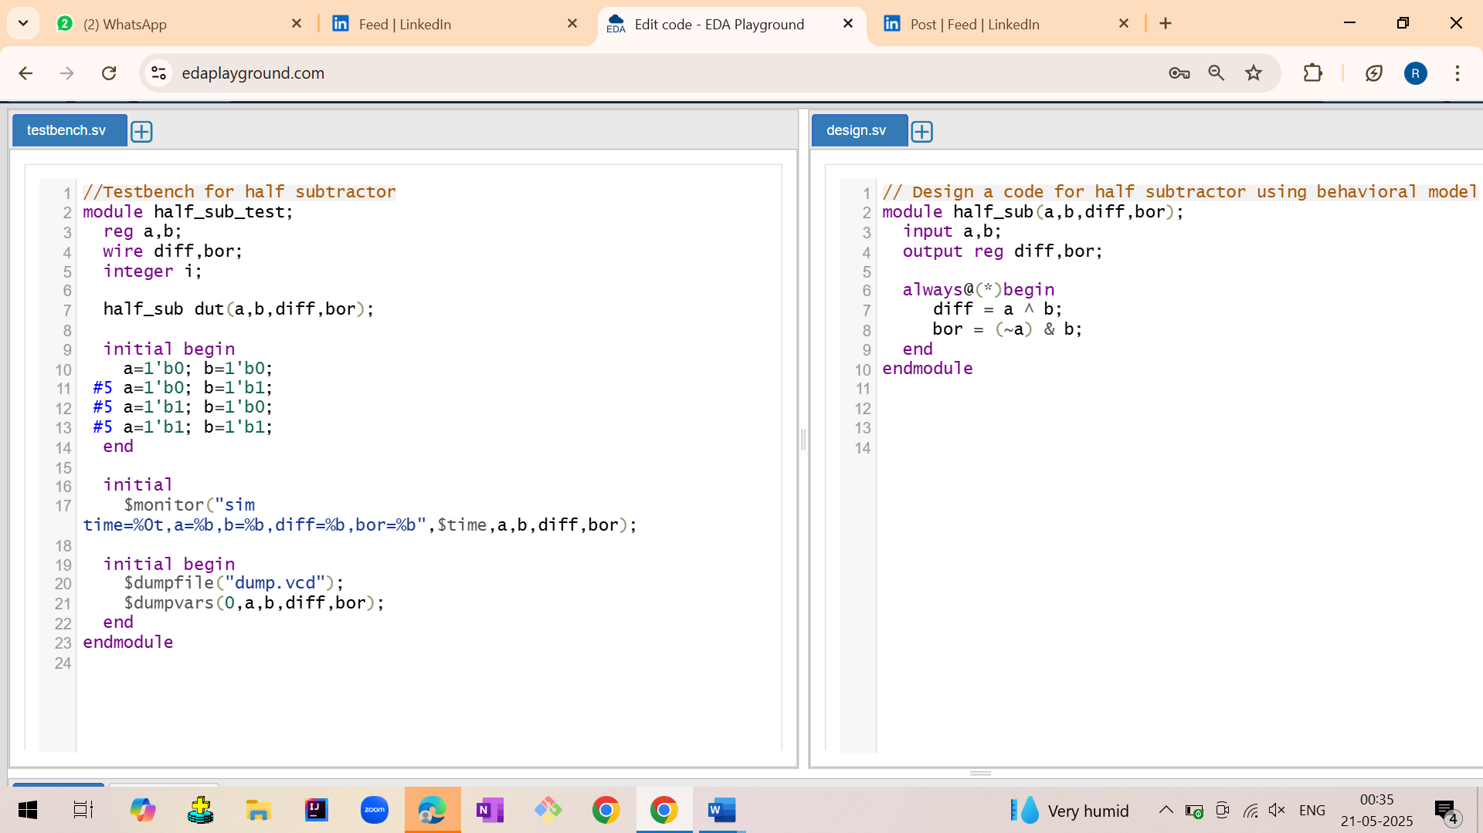

Output:

sim time=0 a=0 | b=0 | diff=0 | bor=0  
 sim time=5 a=0 | b=1 | diff=1 | bor=1  
 sim time=10 a=1 | b=0 | diff=1 | bor=0  
 sim time=15 a=1 | b=1 | diff=0 | bor=0

Waveform:

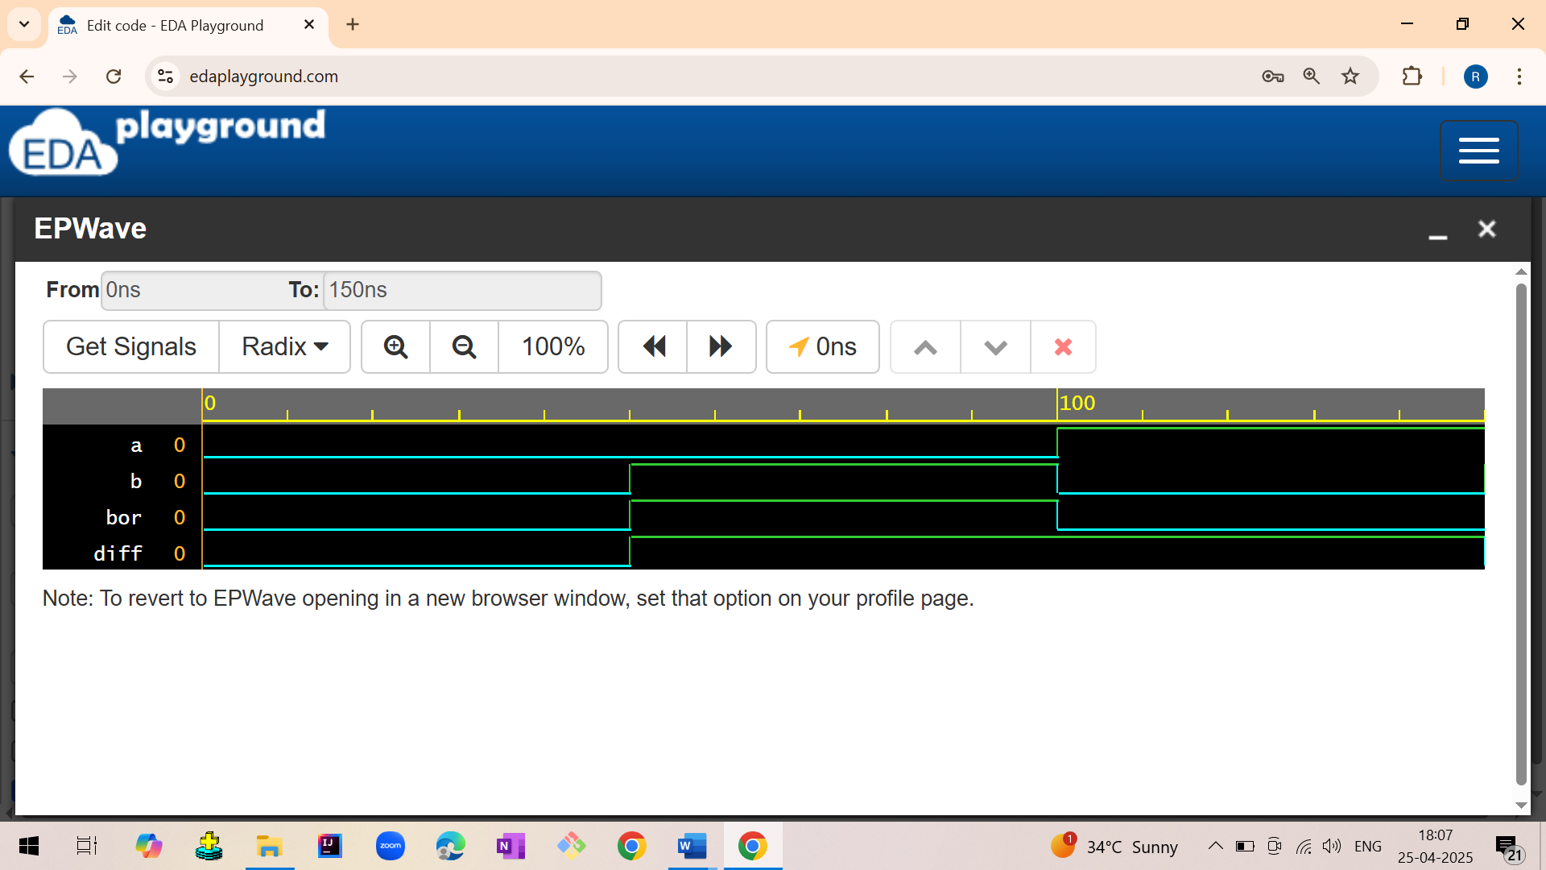

3.2 FULL SUBTRACTOR

3.2.1 Full subtractor using data flow model

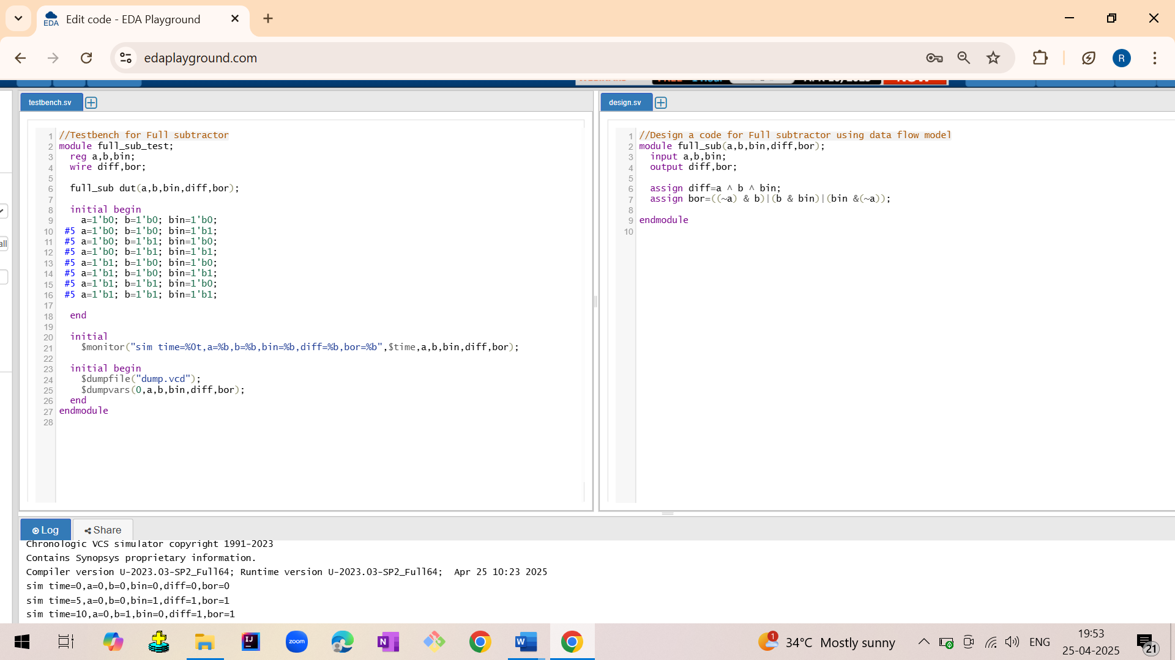

3.2.2 Full subtractor using gate level model

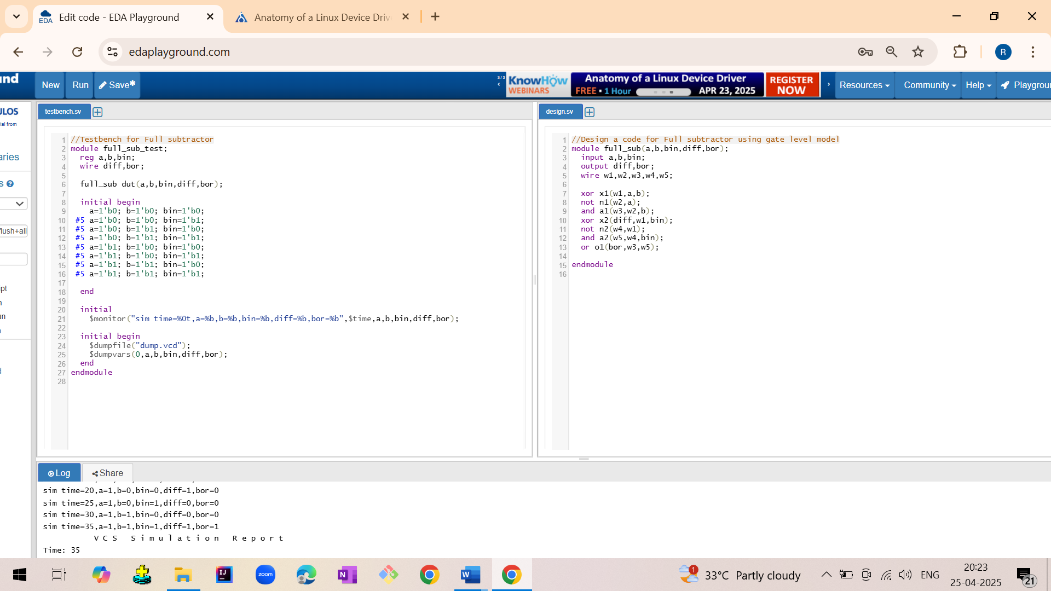

3.2.3 Full subtractor using behavioral model

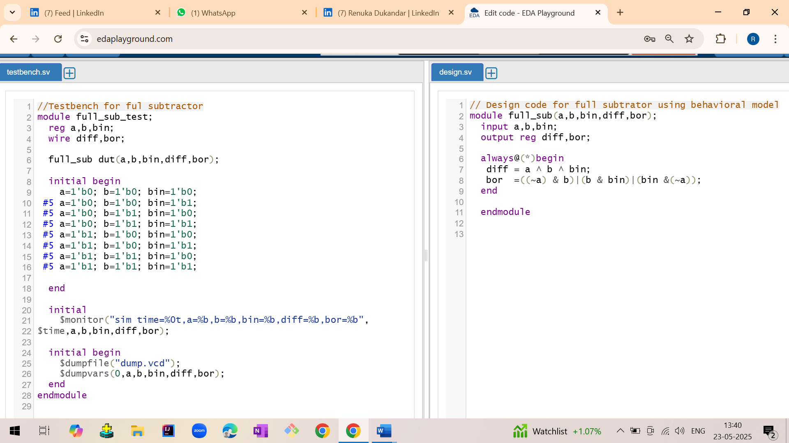

Output:

sim time=0 | a=0 | b=0 | bin=0 | diff=0 | bor=0  
 sim time=5 | a=0 | b=0 | bin=1 | diff=1 | bor=1  
 sim time=10 | a=0 | b=1 | bin=0 | diff=1 | bor=1  
 sim time=15 | a=0 | b=1 | bin=1 | diff=0 | bor=1  
 sim time=20 | a=1 | b=0 | bin=0 | diff=1 | bor=0  
 sim time=25 | a=1 | b=0 | bin=1 | diff=0 | bor=0  
 sim time=30 | a=1 | b=1 | bin=0 | diff=0 | bor=0  
 sim time=35 | a=1 | b=1 | bin=1 | diff=1 | bor=1

Waveform:

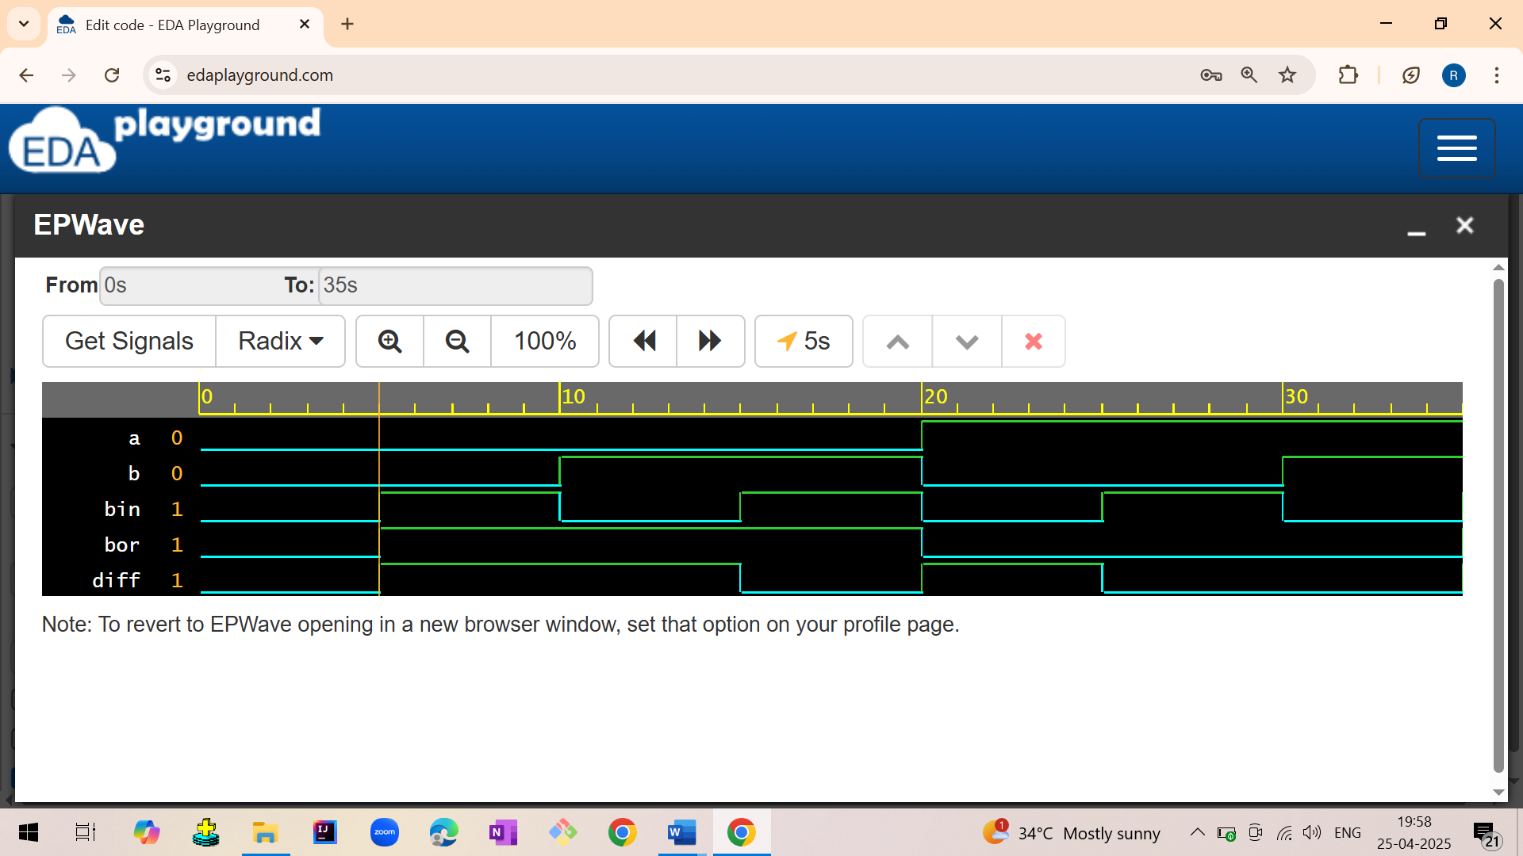

3.3 FULL SUBTRACTOR USING HALF SUBTRACTOR

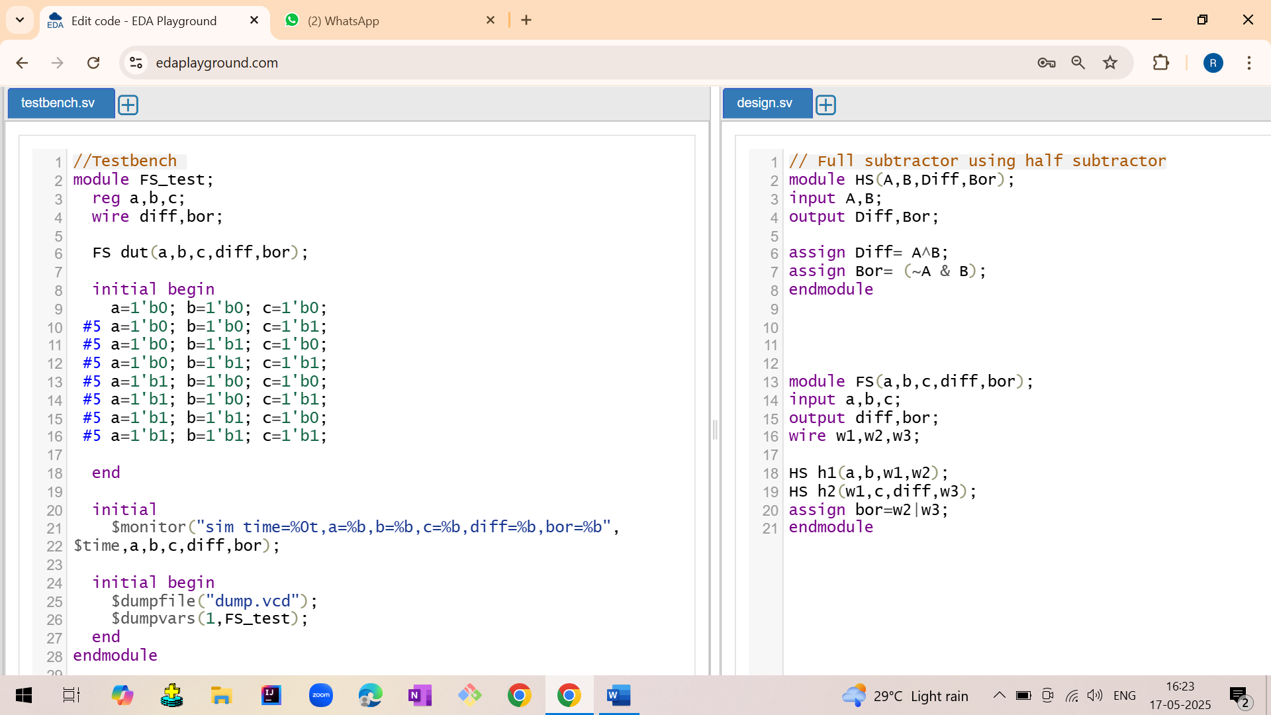

Output:

sim time=0 | a=0 | b=0 | bin=0 | diff=0 | bor=0  
 sim time=5 | a=0 | b=0 | bin=1 | diff=1 | bor=1  
 sim time=10 | a=0 | b=1 | bin=0 | diff=1 | bor=1  
 sim time=15 | a=0 | b=1 | bin=1 | diff=0 | bor=1  
 sim time=20 | a=1 | b=0 | bin=0 | diff=1 | bor=0  
 sim time=25 | a=1 | b=0 | bin=1 | diff=0 | bor=0  
 sim time=30 | a=1 | b=1 | bin=0 | diff=0 | bor=0  
 sim time=35 | a=1 | b=1 | bin=1 | diff=1 | bor=1

Waveform:



3.4 4BIT SUBTRACTOR USING FULL ADDER

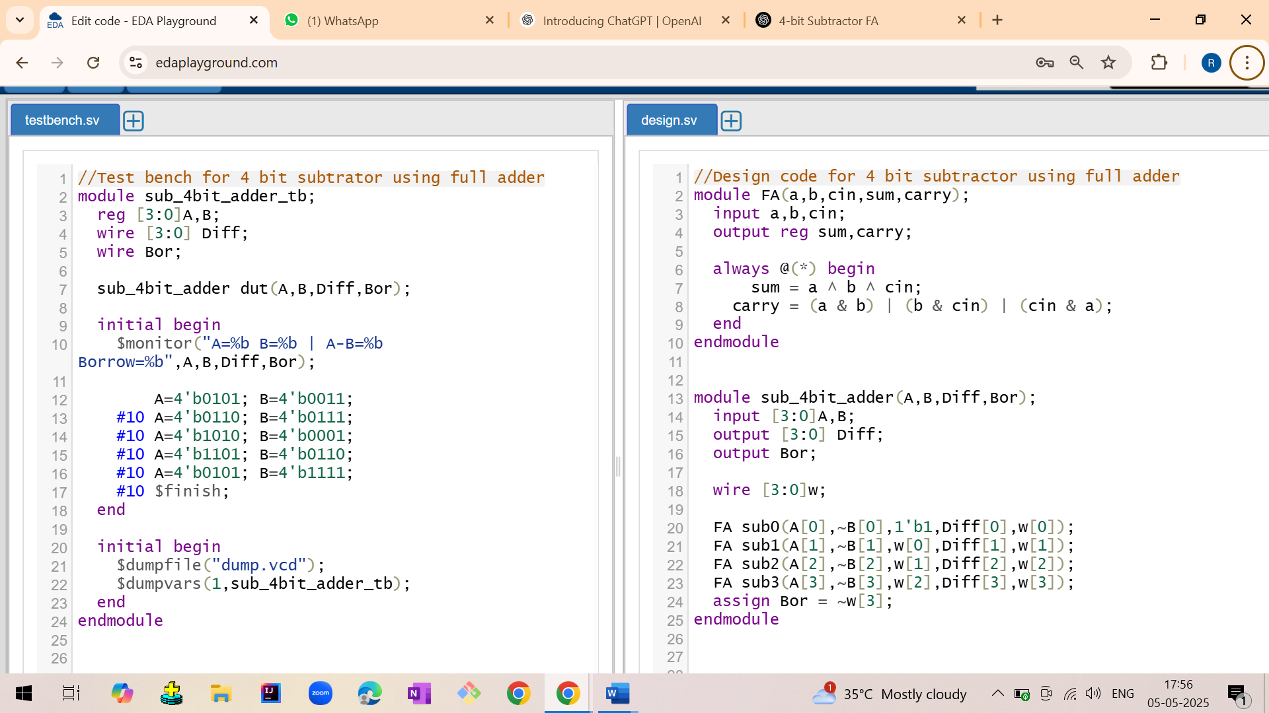

Output:

A=0101 B=0011 | A-B=0010 Borrow=0  
 A=0110 B=0111 | A-B=1111 Borrow=1  
 A=1010 B=0001 | A-B=1001 Borrow=0  
 A=1101 B=0110 | A-B=0111 Borrow=0  
 A=0101 B=1111 | A-B=0110 Borrow=1

Waveform:

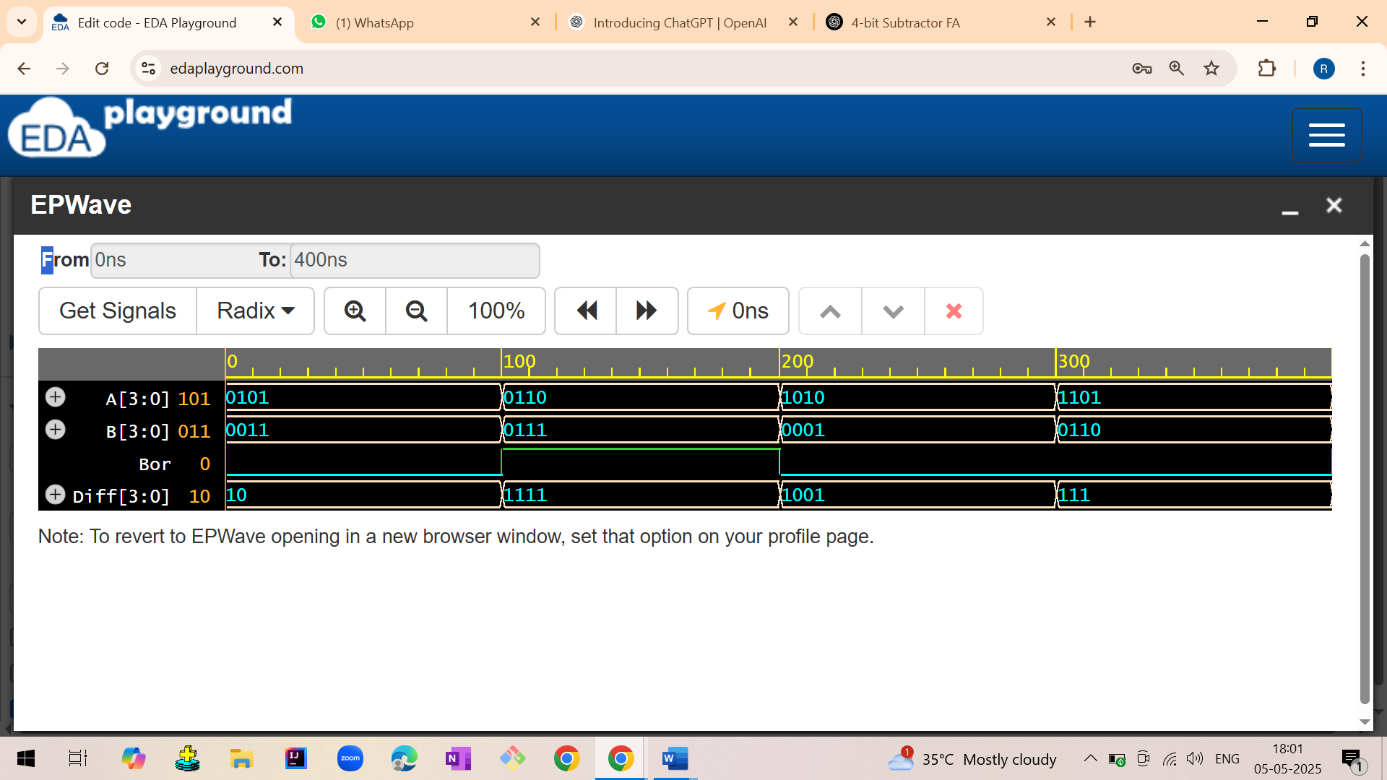

4.MULTIPLEXER

4.1 MUX 2:1

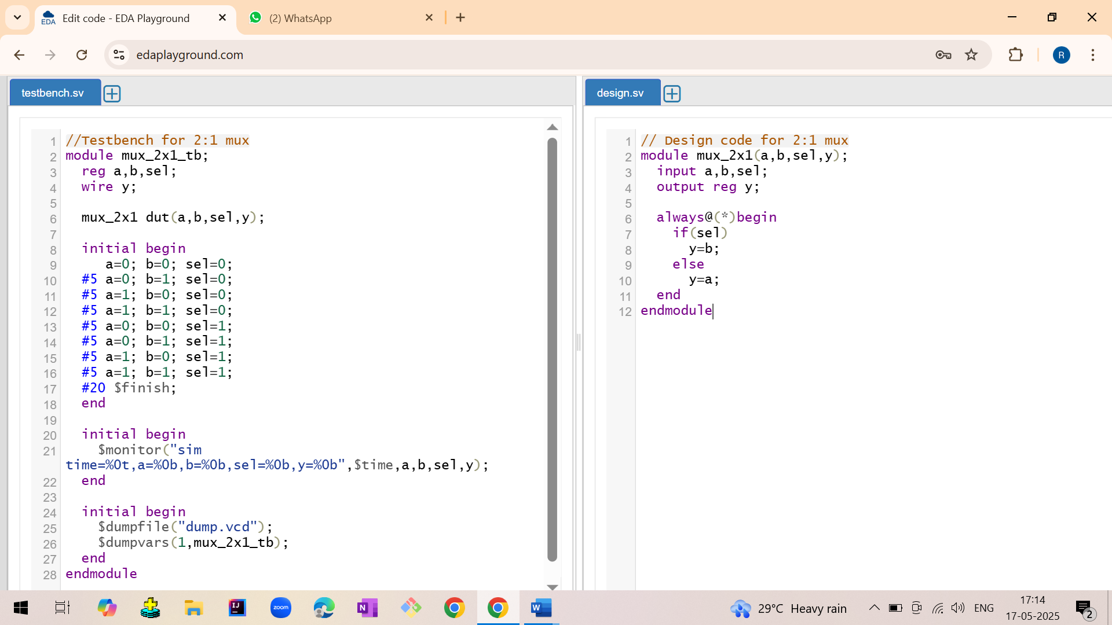

Output:

Sel=0, in=00, y=0

Sel=0, in=01, y=0

Sel=1, in=10, y=0

Sel=1, in=11, y=1

Waveform:

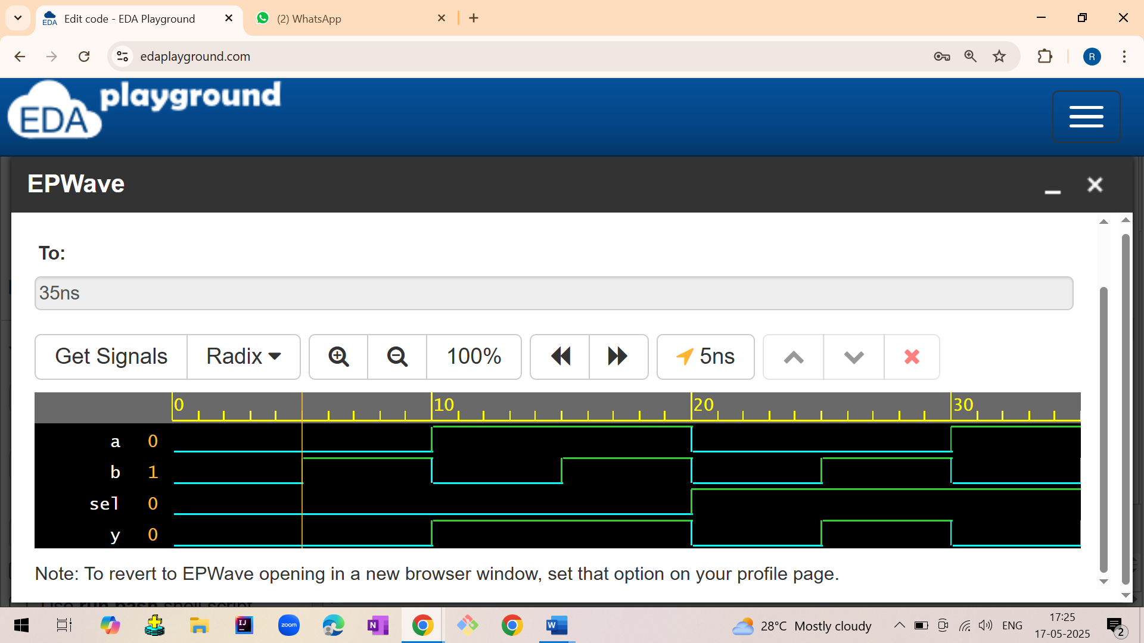

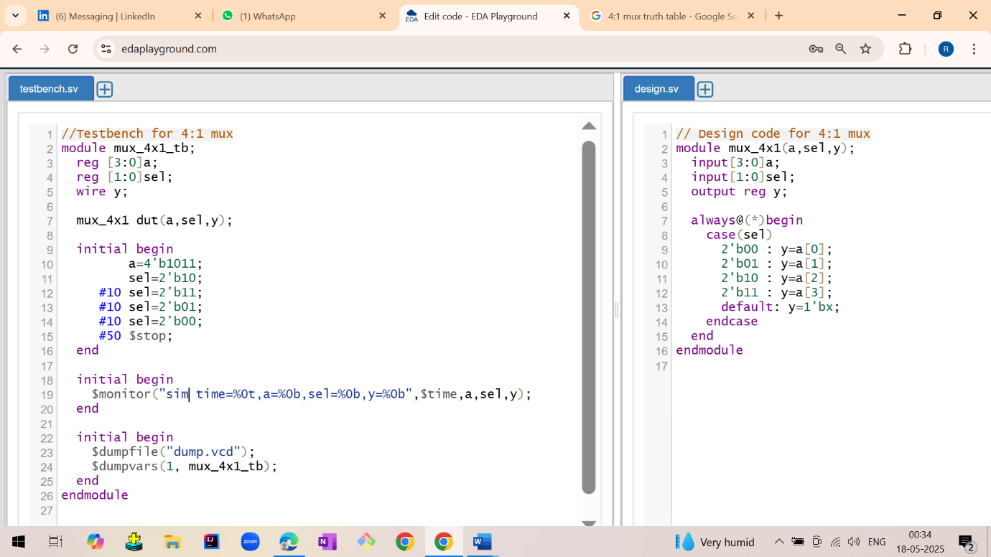4.2 MUX 2:1

Output:

sim time=0 | a=1011 | sel=10 | y=0  
 sim time=10 | a=1011 | sel=11 | y=1  
 sim time=20 | a=1011 | sel=01 | y=1  
 sim time=30 | a=1011 | sel=00 | y=1

Waveforms:

